

Uniform & Appearance

All students are expected to take pride in their uniform and appearance, creating a positive first impression of the school. Students are expected to take responsibility for their own appearance, upholding policy and showing themselves to have the highest standards at all times.

**Appearance**

**Make-Up** - No make-up allowed, it will be removed if seen.

**Additional cosmetic items** - No false eyelashes, no false nails, no nail varnish.

**Hair** - No extremes of hairstyles in terms of colour or cut.

Hair colour should be natural.

**Jewellery** - Two pairs of ear studs in lower lobe allowed. One small nose stud allowed. No other jewellery permitted including tongue piercings - if a student presents with an additional piercing, sanctions will be applied and the jewellery removed without question.



**Uniform**

**Blazer** -JSTC logo black blazer to be worn at all times.

**Tie** -JSTC logo tie in House colours to be worn at all times.

**Jumper** **(Optional)** – Any black jumper without any logos can be worn under the blazer. Hoodies or alternative jumpers are not allowed.

**Trousers** -Traditional/slim fit trousers only. No skinny fit, cropped, jeans or flares.

**Skirt** -JSTC logo black pencil skirt to be worn just above the knee. Please ensure the correct size is bought so as it sits no higher than 1” (2.5cm) above the knee. If skirts aren’t worn at the correct length, students will be asked to buy a new skirt or wear the school trousers.

**School Shoes** – Formal smart leather / leather type shoes only,

**Example of acceptable footwear**

**Examples of unacceptable footwear**

Footwear must appear to be shoe like rather than trainer like. Shoes made by sportswear manufacturers (eg Converse, Vans, Nike, Adidas etc) are deemed to be trainers. Please be aware that some shoes that are marketed as school shoes may not be acceptable at JSTC.

No trainers, canvas shoes, boots, heels allowed.

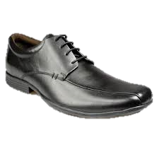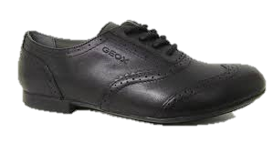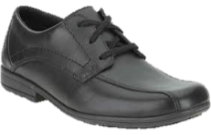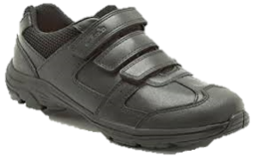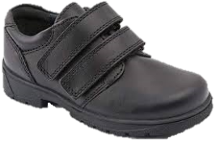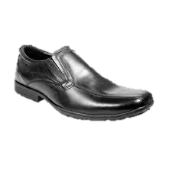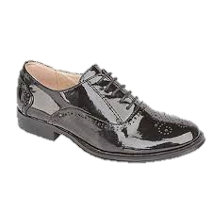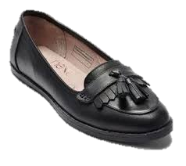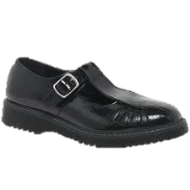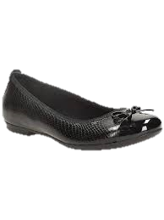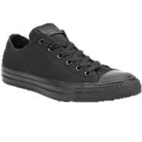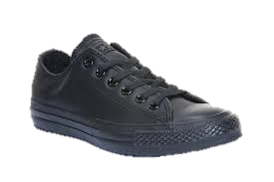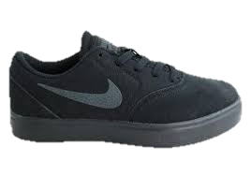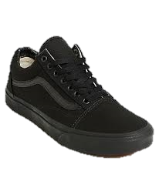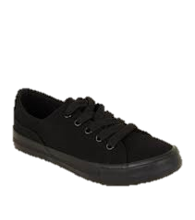



PE Kit

**Boys PE**

Black & gold JSTC polo shirt

Black & gold JSTC unisex quarter zip track top

Black JSTC shorts

Black & gold JSTC socks knee length

**Optional**

Black & gold JSTC hoody (this item is NOT to be purchased instead of the quarter zip top)

JSTC tracksuit bottoms

**Girls PE**

Black & gold JSTC polo shirt

Black & gold JSTC unisex quarter zip track top

Black JSTC skort

Black & gold JSTC socks knee length

**Optional**

Black & gold JSTC hoody (this item is NOT to be purchased instead of the quarter zip top)

JSTC tracksuit bottoms

JSTC leggings (to be worn under skort if preferred - not to be worn on their own)

**Additional Items**

Football boots

Astro Trainers – for Astro Pitch

Trainers – non marking

Shin pads must be worn for football/rugby/hockey

**All uniform should be clearly marked with your child’s name**

Classroom Equipment

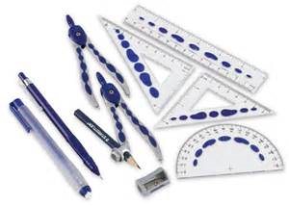

**Fully Stocked Pencil Case**

Pens pencils ruler

Glue pencil sharpener protractor

Compasses highlighter pens eraser

Colouring pencils

• , /angle measurer

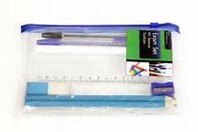

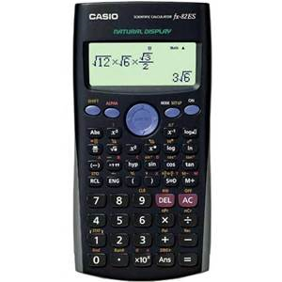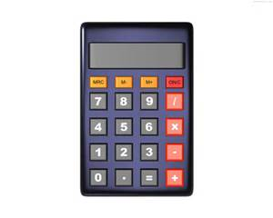

x

**Calculator**

Calculator needs to be a Scientific Casio Natural Display model

• , /angle measurer

**Reading Book**

All Students in Years 7, 8 and 9 should have a suitable reading book in their bag every day

• , /angle measurer