Respect - Responsibility – Resilience

John Spendluffe Technology
College
Special Educational Needs and Disabilities (SEND)
Year 6 Transition Booklet
2023

What is the SEND Department?
Our school has a department that is designed to help you with your learning and emotional needs. There are 18 members of our team, including Mrs Forman who is our SENDCo, (Special Educational Needs and Disabilities Co-ordinator), Miss Deeley who is our Assistant SENDCo and Miss Pick who is our Administrator. We help students, both in the classroom and, sometimes we may take a small group of students and work with them separately. This might be to help you with your reading, writing, numeracy and emotions. These lessons are called interventions.
At JSTC, we understand that moving from your Primary to Secondary school can feel a bit scary, you might feel nervous, and this is normal to feel this way. So our team of Learning Support Assistants (LSAs), together with the Year 7 Progress Team, are here on hand to make your move as smooth and as enjoyable as possible.

What is a Progress Team?
At JSTC, each year group has a Progress Team that you can speak to if you feel nervous, anxious or need to talk to an adult about something that has happened in school. The Progress Team has three members of staff. There is a Progress Leader, Deputy Progress Leader and a Pastoral Leader. They are always around school and always on hand. For Year 7, the Progress Team is:-
Mrs Miller - Progress Leader
Mrs Miller is also a Maths teacher here at JSTC. She has a real passion for Maths and for helping students and being someone you can go and talk to. Mrs Miller also talks to and meets with parents/carers as well as attending meetings.
Mr Reyes - Deputy Progress Leader
Mr Reyes is also a Spanish Teacher. Mr Reyes is fluent in Spanish as he comes from Mexico - a Spanish speaking country. You will see Mr Reyes out and about, around school when he is not teaching, and sometimes he covers for other teachers in their lessons. Mr Reyes is usually based in the MFL rooms.
Miss Lynch - Pastoral Lead
Miss Lynch has recently become the Pastoral Lead for Year 7 after working in the SEND Department. Miss Lynch is always out and about and is always available for you to go to if you have a problem that you would like to talk about. Miss Lynch also talks to, meets with parents/carers, and attends meetings with Mrs Miller.

As we move through this booklet, we will show you various parts of the school so that you can see what to expect when you arrive for your transition visit and your transition days with us.
Before we do that, let us introduce you to Mrs Forman, Miss Deeley and Miss Pick.

Mrs Forman
Special Educational Needs and Disabilities Co-ordinator (SENDCo)
Mrs Forman is the person responsible for children and young people with Special Educational Needs and Disabilities. Her job is helping all of our pupils who may need some extra support and co-ordinating this, whilst they are here at John Spendluffe Technology College. Mrs Forman also teaches within our Modern Foreign Language department and is an Assistant Head Teacher. Mrs Forman also holds the National Award for SEND.

Miss Deeley
Assistant SENDCo/Learning Support Assistant
Miss Deeley deals with the day-to-day running of the SEND Department. Her job is to look after the LSAs and to make sure that all the students that we support are looked after, and have everything they need. Miss Deeley also talks to parents/carers, other schools, she also attends meetings in school. Miss Deeley also talks with hospitals and various professionals and makes referrals to them where necessary for our students. Miss Deeley is also an LSA herself, and is a specialist in History.

Miss Pick
SEND/LAC Administrator
Miss Pick deals with the administration part of SEND, which includes filling in forms, speaking to teachers and arranging meetings for Mrs Forman, Miss Deeley and Mrs Jackson, (Lead Professional for Looked After Students). Miss Pick also talks to parents/carers and students. Miss Pick looks after students when they come to see us if they need a quiet area, or if they need to borrow a laptop or a reading pen for their lessons. Miss Pick is also in our Homework Club on a Monday and Wednesday, where she is on hand to help our students if they need support in doing their homework.
Familiar Faces
As you start to get to know your Progress Team and all of your Teachers, you will also see around school our Head Teacher, Mr Curtis and our School Dog, Bailey. Mr Curtis is always around school both during lesson time, to make sure everyone is where they should be and in the classroom learning, and outside at break and lunch times. Bailey is usually by his side.

Mr Curtis – Head Teacher
- Mr Curtis joined JSTC in September 2021
- He teaches Art and Photography
- He likes students to talk to him and say hello!
- Mr Curtis likes to read and he supports Lincoln City Football Club

Bailey – Our School Dog
- Bailey loves the attention from the students
- He is well behaved and follows commands.
- He loves treats.
- Bailey will be celebrating his 2nd birthday soon!

Our School Site
We know that coming to a new school can be scary. To make this experience a little less scary, we would like to show you how our school is set out. We know that this is going to look so much bigger than your Primary school and we do not want you to feel overwhelmed by this. So, we would like you to use this map to help you familiarise yourself with our school layout.

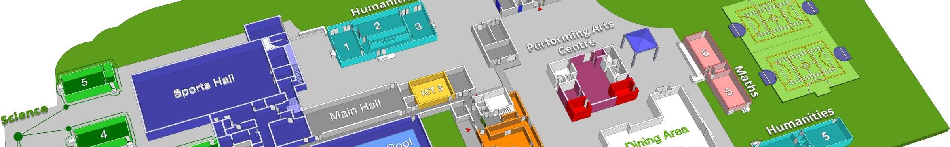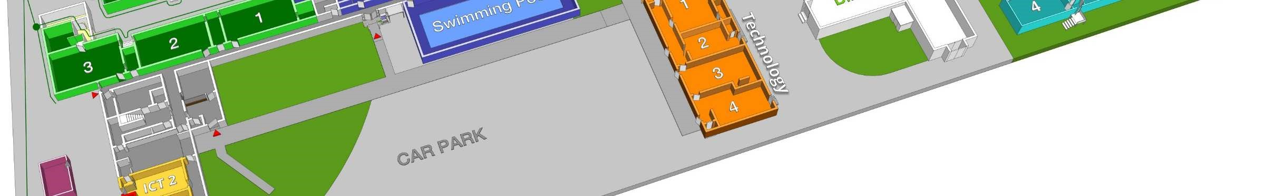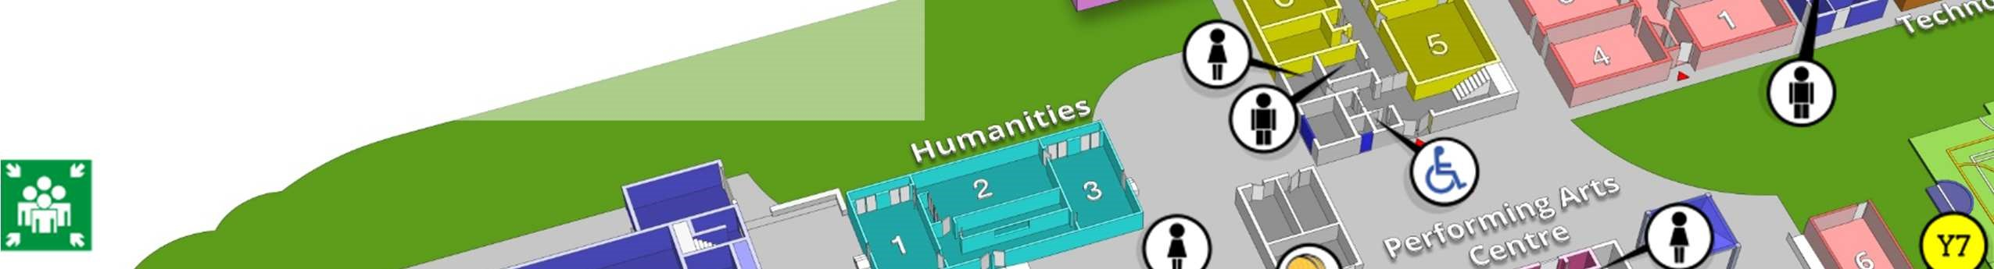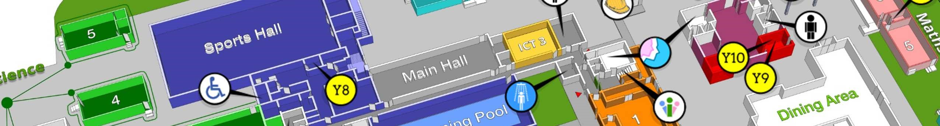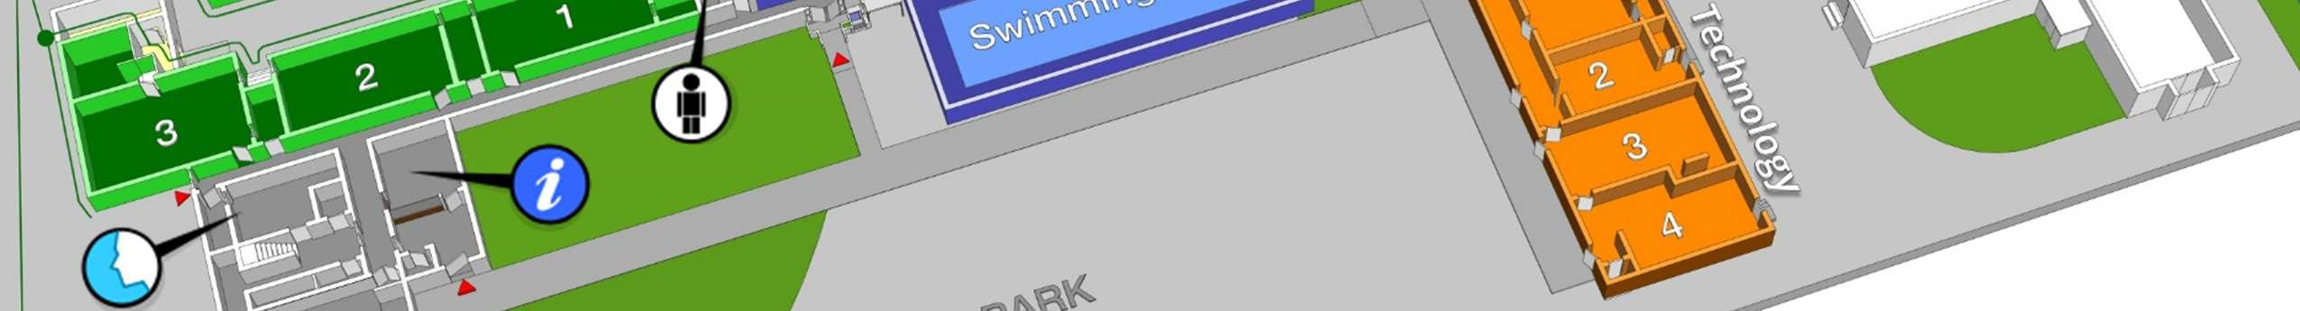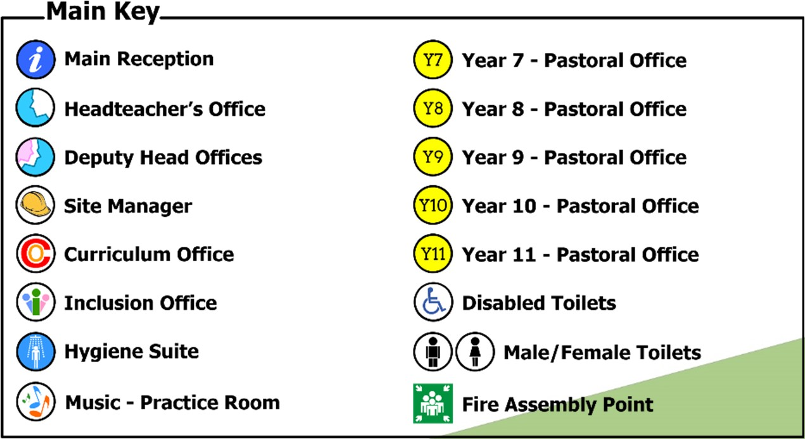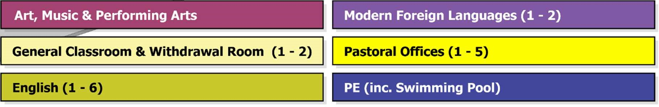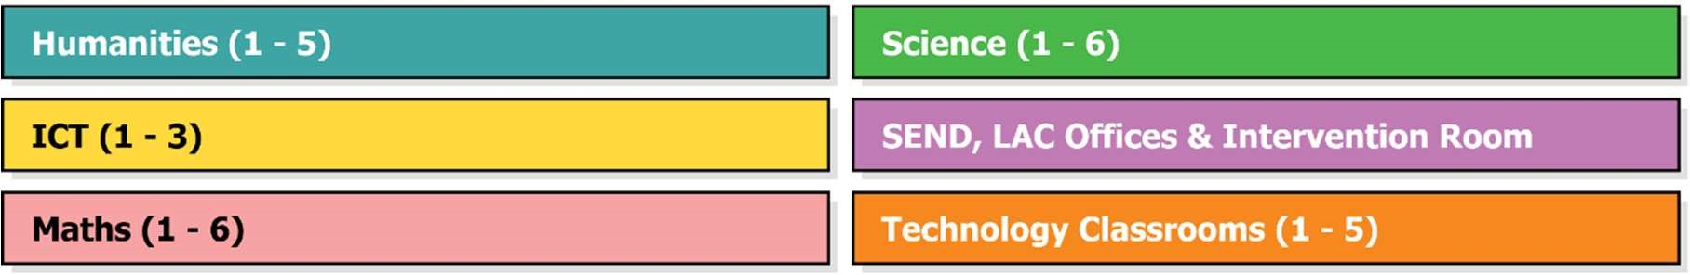

English Block

Upper Floors

You will see from the map that the SEND Department is on the second floor in the English Block. This is where you can find Miss Deeley and Miss Pick. They are always on hand if you need support.
The Year 7 Progress Team office is in between Maths 5 and 6 on the map. This is where you can find Mrs Miller and Miss Lynch. Mrs Miller’s classroom is Maths 5. Mr Reyes is normally situated in Modern Foreign Languages, but he is usually out around school if he isn’t teaching Spanish or covering other lessons.

Our School
Here, we would like to show you some of our school setting. If you had the opportunity to come and visit us for our open evening in September 2022, you will have probably seen most of our school. However, if you didn’t, we would like to show you some of the features of JSTC. You can also use the map on the previous page to try and locate them so you have a better idea of where things are ready for September 2023.

Learning Support
Our Learning Support rooms are located on the second floor of our English block. We have two rooms, one where Miss Pick works and looks after students when they need support and one where we have our intervention lessons.
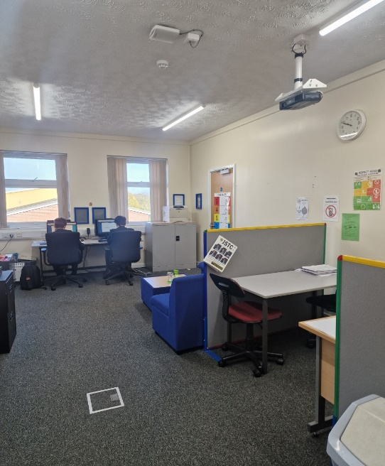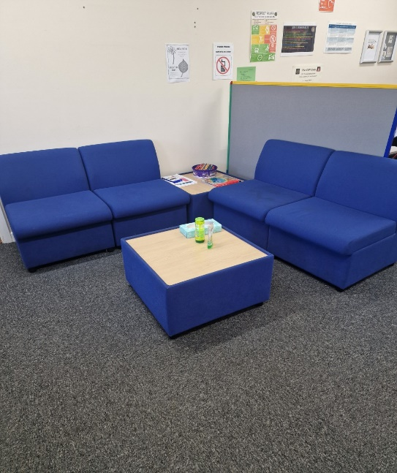
Learning Support 1 Learning Support 1 (Quiet Zone)

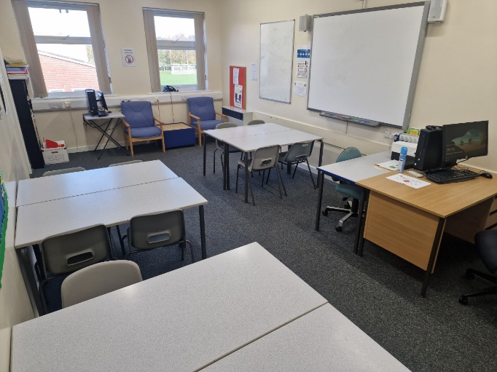

Learning Support 2 (Intervention Room)
Classrooms
This is what some of our classrooms look like.

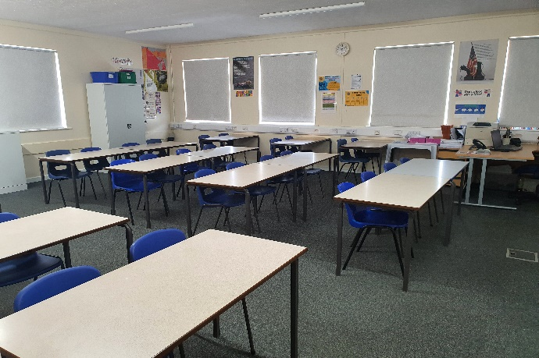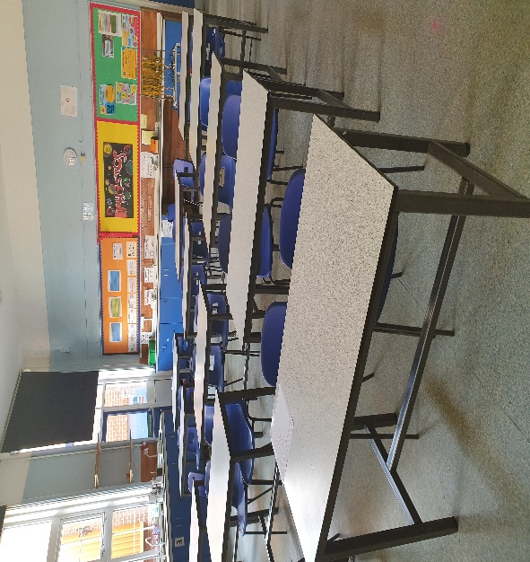
English/Maths Classroom Science Classroom

PE/Sports
We do lots of sports at JSTC. These include, Football, Rugby, Rounders, Hockey, Netball, Basketball and Dodgeball and much more! We also do athletics and have a Sports day where our three houses Discovery, Enterprise and Endeavour compete for the house cup in Athletics.

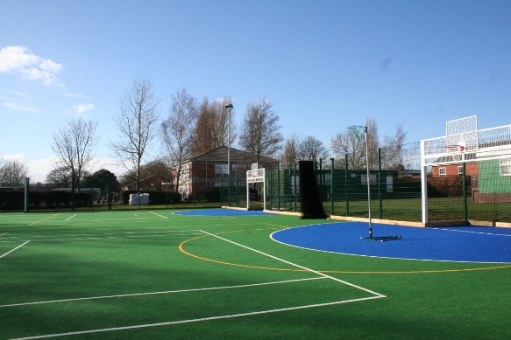
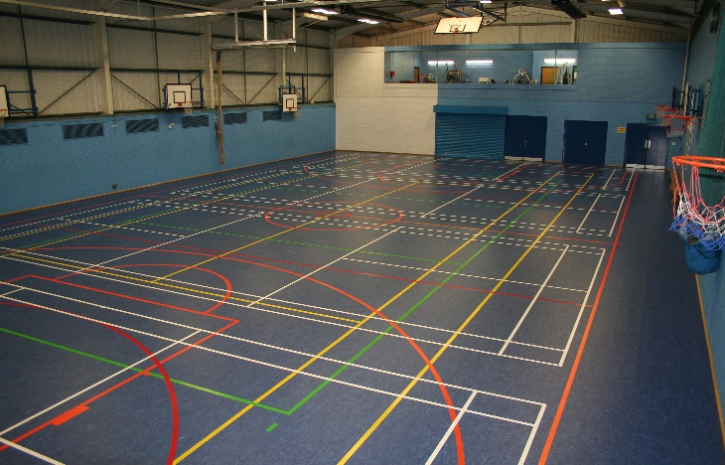
Sports Hall AstroTurf

Canteen
Our canteen has lots of different foods to choose from. This includes items from bacon rolls and bagels for breakfast, to pizza, bagels and sausage rolls at break time and sandwiches, salads, hot meals and pizza at lunchtime. There is something to suit everyone. We also offer vegetarian options if you don’t like or don’t eat meat.

Our new canteen cashless payment system will be new for 2023! All you will need is your finger to pay for your lunch .
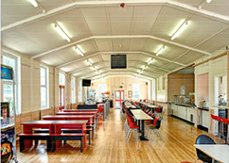

The canteen is open from 8am for breakfast, 11.20am for break and 1.45pm for lunch. Here is a small selection of what we offer.
Breaktime adds to the menu, sausage rolls, pizza and cheese and ham bagels most days. Hot and cold drinks are also available.
There is a good selection of items on our breakfast menu including bagels, bacon rolls and hot drinks.
There is a wide selection of hot and cold items on our lunch menu. Both hot and cold drinks are available at this time too.

Our School Day

Our current school timetable is on a 2 week rotation, Week 1 and Week 2. Our school day, is made up of five periods of learning. Your day starts with your Tutor Time. This is where you will meet your Form Tutor so that they can do the register and discuss our Student Bulletin. This is where important information is logged by staff members that you may need to know about. You will also be able to discuss any school issues with your Form Tutor if you feel you need to.

Below is an example timetable of a normal day at JSTC. Between each lesson you will have a 5 minute changeover period which will help you to get to your next lesson on time. Break is at 11.20am for 20 minutes and Lunch is at 1.45pm for 45 minutes. You only have one lesson after lunch and the day ends at 3.35pm. You will get a timetable made specifically for you on your first day with us in September. You will see on the example that each lesson shows the teacher initials, room number and the lesson name. If you look at the map, you can see where you might be travelling to and from each day!

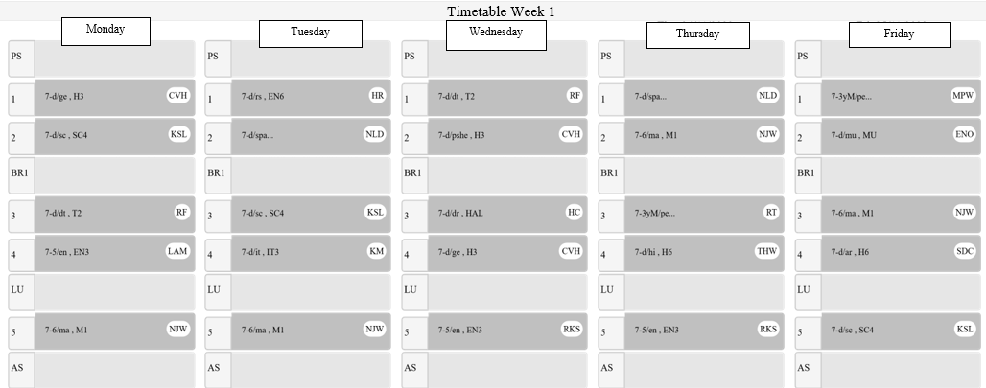
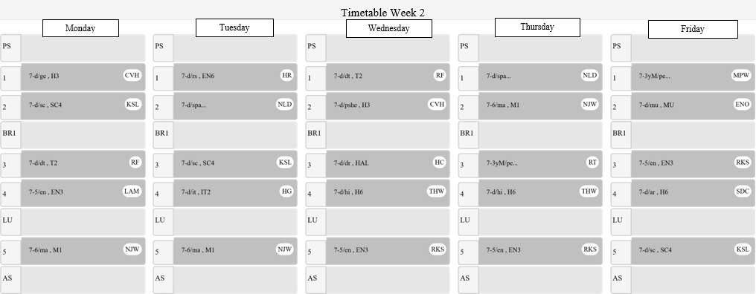
We don’t expect you to know where you are going or how to get there straight away, so you will be given a timetable on your first day at JSTC. We encourage all of our students to keep this with them at all times. Please don’t worry if you lose it, if you ask your Form Tutor at Tutor Time, they will print another one for you.
It is normal to get confused as to where your new classrooms are but don’t worry, we will give you some time to get used to your new school and there will be lots of staff members on hand to point you in the right direction.
Our school day times are as follows:
TIME OF DAY | WHAT HAPPENS HERE?
8.55am – 9.10am | Tutor Time:  Your tutor will give you important messages, check you are wearing the right uniform and that you have the right equipment for learning
9.10am – 9.15am | Lesson Changeover
9.15am – 10.15am | Period 1
10.15am – 10.20am | Lesson Changeover
10.20am – 11.20am | Period 2
11.20am – 11.35am | Break Time
11.35am – 11.40am | End of Break and movement to next lesson
11.40am – 12.40pm | Period 3
12.40pm – 12.45pm | Period 4
1.45pm – 2.30pm | Lunch Time
2.30pm – 2.40pm | End of lunch and movement to next lesson
3.35pm | End of the school day

Equipment for Learning

One of our expectations of our students here are JSTC is that you are prepared and ready for learning. Below is some information about the standard equipment you will need for all of your lessons. You will also be need to bring with you an appropriate reading book every day. This is part of our Literacy programme and, you will be expected to read for the first 5 minutes of each lesson.
Below is an example of the basic equipment you will need each day:-

Remember – you will need a reading book similar to this one. It doesn’t have to be Harry Potter; it can be your favourite book you like to read. However, it must be a proper book!
Although we expect our students to have their own equipment, we do have a stock of pre-filled pencil cases, which can be bought at our Main Office should you forget yours. We also sell scientific calculators. These will be needed for both Maths and Science.

School Uniform

At JSTC, we take pride in how smart our uniform looks. All of our students take pride in their uniform and, how they present themselves. This creates a positive impression of our school. This means that, as an expectation of our school, students must take responsibility for their uniform, and their actions whilst wearing it, both in school and outside of school. Keeping with the highest standards of JSTC at all times.

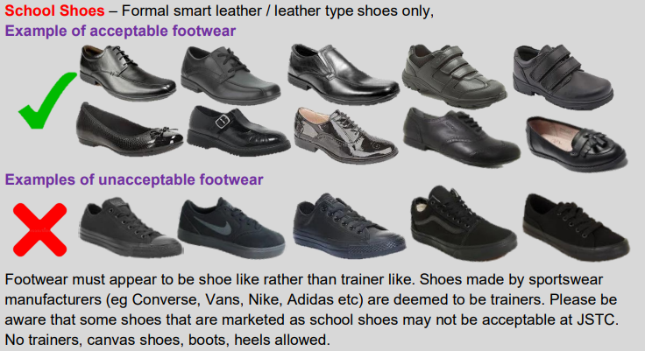
Appearance

Make-Up | No make-up is allowed, it will need to be removed if seen
Cosmetic items | No false eyelashes, no false nails, no nail varnish
Hair | No extremes of hairstyles in terms of colour or cut. Hair colour should be natural
Jewellery | One pair of ear studs in lower lobe allowed, no other jewellery permitted.  No tongue piercings - If a student presents at school with this type of piercing, sanctions will be applied and the jewellery will need to be removed without question.
Blazer | JSTC logo black blazer to be worn at all times – it can be removed in lesson with permission from your class teacher
Tie | JSTC logo tie in House colours to be worn at all times
Jumper (Optional) | JSTC logo black V-neck jumper can be worn under the blazer - hoodies or alternative jumpers are not permitted
Trousers | Traditional/slim fit trousers only. No skinny fit, cropped trousers, jeans or flares
Skirt | JSTC logo black pencil skirt to be worn just above the knee.  Please ensure the correct size is bought so as it sits no higher than 1” (2.5cm) above the knee. If skirts aren’t worn at the correct length, students will be asked to buy a new skirt or wear the school trousers.

Wear Your Uniform With Pride

Behaviour

At secondary school, everything is going to be different and will take time to get used to. The one thing that will stay the same from Primary school is our expectation of good behaviour. We expect all our students to follow our school rules and expectations and to follow instructions given by ANY member of staff around the school site.

Here at JSTC, we have high expectations for behaviour especially in the classroom. We have our 10 Classroom Rules that all students must follow. These rules are listed below and are also situated in all of our classrooms.

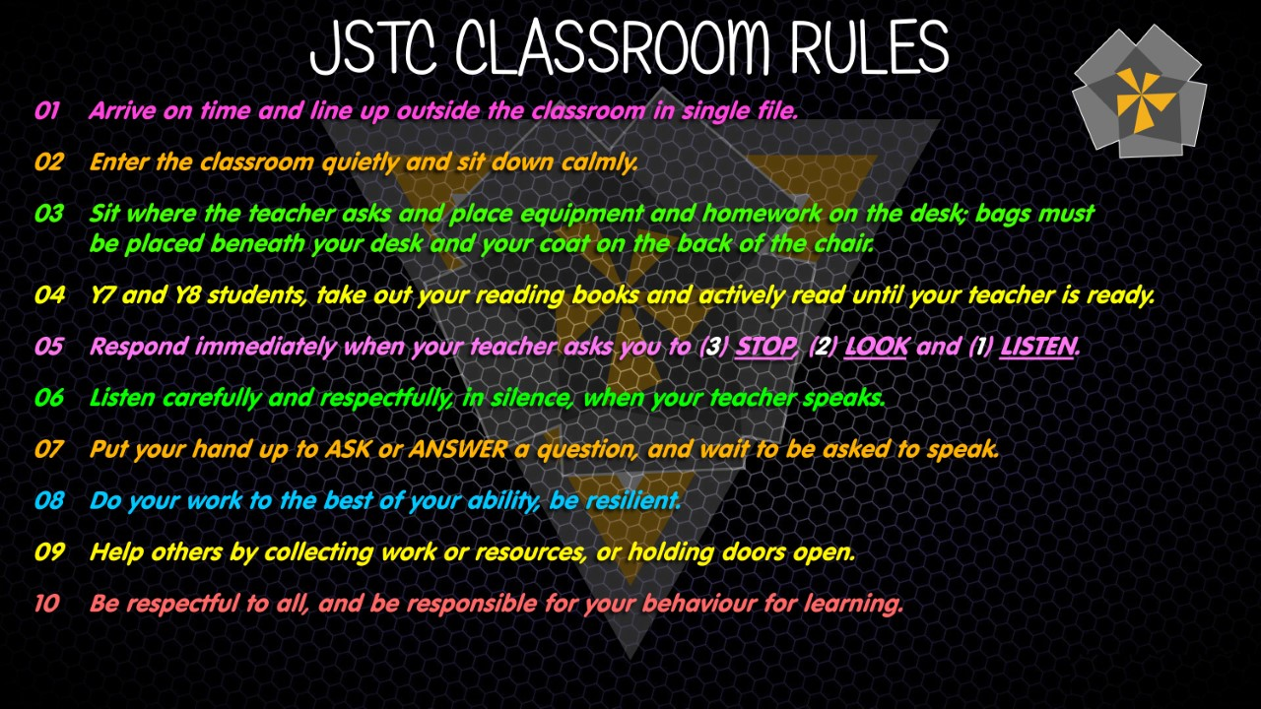

If your behaviour is as expected, both in the classroom and when moving around school, you will be awarded a ‘Positive’ point on our Bromcom My School App. These can be collected and then put towards a reward from our Reward Store. If, your behaviour is not as expected, a ‘Negative’ point will be put on instead. This may result in a detention, which will vary in its length, depending on the reason.

We want you to get as many Positive points as you can and we don’t want to see you in detentions. Below are some of our standard expectations we like you to follow.

- Always attend school and be on time for all lessons
- Remain on school site all day, unless you have permission to leave school
- Be in the right place at the right time
- Wear the correct school uniform and bring the right equipment each day
- Log in to Class Charts daily to check for any messages and homework
- Complete homework on time to the best of your ability
- Catch up any work missed due to absence promptly
- Be creative, open minded, resilient, hardworking and independent
- Ensure your mobile phone is turned off and kept in your bag unless in the Food and Phone Zone
- Treat other people, property and the school environment with respect and take personal responsibility for your actions.
- Show kindness at all times.
- Inform your form tutor if you have any problems which may affect your safety or progress
- Always follow the JSTC Respect Rules on the posters around school. This is to be followed both in and outside of lessons and comply with the sanctions system for behaviour.

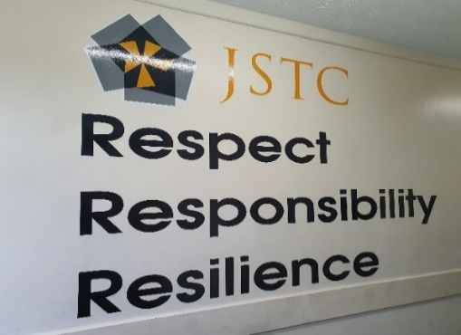
As you walk round our school, you will see our motto on some of the walls in different places. This is the one in the English block.

Looking Forward

It won’t be long before you will be coming for your transition days with us in July. Below is a blank space for you to write down any questions that you might want to ask the teachers when you are here.

We hope that our booklet has given you a little bit of information about what school is like at John Spendluffe Technology College. We are looking forward to meeting you and supporting you on your journey through secondary school with us.

We can’t wait
to see you
in
September
2023!!

Respect - Responsibility – Resilience

John Spendluffe Technology
College
Special Educational Needs and Disabilities (SEND)
Parent Information
September 2023

If you require this booklet in large print, please contact the SEND department send@jstc.org.uk and we will send this to you

Foreward

John Spendluffe Technology College prides itself on being a fully inclusive school. Our SEND Department strive to support all of our students, predominantly those with special educational needs. We are committed to supporting parents and carers, as well as students, with every aspect of their child’s needs and we are happy to discuss these with you.

We have a dedicated team of Learning Support Assistants who work within both the classroom and, in small groups and 1:1 environments. They are constantly training and have a wealth of knowledge of all types of needs in neurodiversity, physical disabilities and medical conditions. These include, but are not limited to:

- Autistic Spectrum Disorder (ASD)
- Attention Deficit Hyperactivity Disorder (ADHD),Pathological Demand Avoidance (PDA) and Oppositional Defiant Disorder (ODD)
- Dyslexia, Dyscalculia and Dyspraxia
- Chromosome Deletion and Global Developmental Delay
- Tourettes Syndrome
- Asthma, Epilepsy, Cystic Fibrosis, Diabetes (Type 1 and Type 2)
- Allergies and Epipens
- Ehlers Danlos Syndrome, Hypermobility, Cerebral Palsy
- Visual and Hearing Impairments

We know that during this time of your child’s educational journey, it can be daunting for you. We have put this booklet together to try to answer some of our frequently asked questions by parents/carers and, to try and ease your worries and concerns your child moves from Primary school to our Secondary school setting.

If you have any further questions, regarding your child’s transition, that is not covered in this booklet, please do not hesitate to contact us at send@jstc.org.uk. We aim to return any messages we receive within 24 hours during term time.

Mrs P Forman Miss J Deeley SENDCo/Assistant Head Teacher Assistant SENDCo/LSA

Our School

John Spendluffe Technology College has been serving the community for many decades and is fully committed to offering an inclusive and open entry policy to local young people. We pride ourselves on our values of Respect, Responsibility and Resilience, which we hope will remain a consistent part our students’ JSTC journey and beyond in their future. These values are part of all that we do, from celebrating success to promoting positive behaviour.

As a non-selective school, we offer a broad and balanced curriculum, which allows the students to become the best that they can be academically and creatively. All our staff pride themselves on our Quality First Teaching and Learning Support Assistant (LSA) support. We encourage staff to continually develop their knowledge and skills in the form of Continued Professional Development (CPD) to enhance their professional practice. All of our staff are on hand and are able to provide support to all of our students, not just academically, but also emotionally, across all abilities. Our aim is to help all of our students unlock their potential, and to help them prepare for the future.

At JSTC, we have our in-house SEND department, dedicated to the learning and emotional needs of all our students. We are a team with 21 members, including Mrs Forman who is our SENDCo, Miss Deeley who is our Assistant SENDCo and a Learning Support Assistant and Miss Pick who is our SEND/LAC Administrator. We are on hand to help if you have any queries or questions about your child’s special educational needs or if you need help and advice in this area.

We understand that choosing the right school that will meet the educational and emotional needs of your child are paramount. In this part of the booklet we will tell you a little more about the type of support that is on offer from our department, in readiness for your child starting with us in September.

Respect - Responsibility – Resilience

Transition Days

Before our transition days, your child’s Primary school will have had meetings with both the Year 7 Progress team and Miss Deeley our Assistant SENDCo. These meetings are usually with the primary school SENDCo or the Year 6 class teacher. This enables us to get a better understanding of all our students that will be joining us, and to enable us to ensure the right level of support is in place. Where possible we will place students in the teaching group that best suits their abilities.

All Year 6 students that will be joining us in September will have two full days with us at JSTC in July. The dates for these for this academic year are yet to be confirmed. However, these will be after our current Year 11 cohort have completed their GCSE exams.

These two days will not only be a chance for our new Year 7 cohort to be in school with us while the school is still operational, but it will allow us to conduct our standard CATS tests to enable us to ensure that each student is in the right teaching groups for September. The teaching groups are of course not set in stone and can be changed, in light of progress made once this has been observed.

The students will sit Cognitive Ability Tests (CATs) but these will be integrated into a timetable that will also include some structured lessons. We endeavour to deploy some of our LSA team to the classes that we feel will need the most support during these two days.

The days will be packed with things to do, but, from past experiences all of the students have enjoyed them. You may need some extra ears to listen to all the great things they have done!

In Class Support

We understand that during your child’s years at Primary school, they may have had some form of support either in the classroom, or outside of the classroom as an intervention to enhance their learning. At JSTC, we also offer the same support.
Our experienced Learning Support Assistants (LSAs) are based both in the classroom and out, leading interventions during the school day. These are both for educational and emotional needs.
In the classroom, the support given by the LSAs is tailored to the student’s needs. Our team are highly experienced in all aspects of needs and have well adapted strategies for each lesson they support. They will also support the teacher with giving instructions in an appropriate way for the student to understand. They will also reassure students if they are feeling overwhelmed. These are just some of the ways our LSAs work. Each lesson is different and will need to be supported differently.

Interventions

If your child has had some intervention at Primary school and doesn’t have an Education Health Care plan (EHCp), we will look to continue these if we feel after assessment they are needed i.e. if Quality First teaching, (QFT), cannot meet their needs. We have a high proportion of children transition to us with similar needs, so our classroom teaching needs to accommodate them as inclusively as possible. We would like to take the first half term (September – October) to get to know our students and help them to settle into secondary school life. In the second half term (November- December), we will look to observe our students and plan to start introducing interventions that are needed based on our observations and feedback from teachers and our team of LSAs. Interventions can be either in or out of the classroom, individually or in a small group according to its’ nature.

We try to conduct our interventions in a way that does not affect the school curriculum and will look to do them during a time that is beneficial to the student. Our team of LSAs who, in their own rights, have their specialist areas, deliver our interventions programmes. We offer a varied programme, some of which will be continued from Primary School or new ones will be introduced. We are continually adding to our knowledge and resources as a department.

We have listed below our intervention programmes. These are just some of what we can offer here at JSTC and this list is always subject to change as we add to our programmes.
The Anxiety Gremlin - This can be delivered in a group and on a 1:1
basis

The Anger Gremlin - This can be delivered both in a group and 1:1
basis

The Self Esteem Thief - This is usually delivered on a 1:1 basis

Rapid Plus (Literacy) - This can be delivered both in a group and 1:1
basis

Toe by Toe (Literacy) - This is usually delivered on a 1:1 basis

Word Wasp (Literacy) - This is usually delivered on a 1:1 basis

IDL (Dyslexia Friendly) - This is an individual intervention delivered in a
group environment
Typing - This is an individual intervention delivered in a
group environment

Lego Therapy (ASD Friendly) - This is usually delivered in a group environment
Social Skills (ASD Friendly) - This can be delivered both in a group and 1:1
Basis

Feelings Detective - This is usually delivered in a group environment
and is predominantly for our students with ASD

Drawing and Talking - This is a specialised intervention that uses the
(Emotional Support) students own drawings as a way of dealing with their emotions, this is currently delivered 1:1 but after further training, we plan to expand to group work.

FRIENDS - This is usually delivered in a group environment
(Emotional Support) but can be delivered on a 1:1 basis in some circumstances. A 10 session programme, looking at how the mind, body and behaviour interact to influence our experience of anxiety.

ELSA (Emotional Support) - This is a 1:1 session with one of our ELSA (Emotional Literacy Support Assistants) trained members of the team

Workshop Safety - This is a 6 week intervention that looks at how to
use the tools and machinery in our school
workshop safely. This is conducted at Tutor Time

Supported Study - This is an intervention for students who are
unable to do PE as part of their normal
curriculum for medical reasons. This is decided
on an individual basis.

Most of our interventions are done as part of the curriculum. However, there may be times that we need to have parent/carer permission for us to conduct the intervention with students. If this is the case, and should your child require one of these interventions, the LSA that will be conducting this will contact you by classcharts.

If you would like more information on the interventions and how they work and their duration, please do not hesitate to contact us and we will be pleased to discuss this with you.

** All of our interventions are suitable for all students regardless of needs or abilities **

Equipment for Learning

Sometimes, students will forget their basic equipment for learning. At our main office, we do have some pre-filled pencil cases that can be purchased for £1.50. We have scientific calculators that students can purchase for £9.50. Teachers do hold some basic equipment that they can borrow in their lesson.

We know that sometimes students need more than just interventions and may need a little technological help with reading and writing.

Scanning Pens

At JSTC, we now have a number of scanning pens, which will help our students to access reading in the classroom independently. The pen is designed to scan the text and read it back to the student, at a speed that is suitable for them to be able to process this effectively. We introduced these in September 2021 and in the first instance, this was with our KS4 students (Years 9 -11), they have proved to be beneficial and, we have seen improvement in reading across the cohorts. We have now started to introduce these to our KS3 students.

For students that use these as their normal way of working, when they get to Year 11, these are added as an access arrangement and an Exam Scanning Pen can be used in their GCSEs. An example is shown below of both the in class pen and the exam pen.
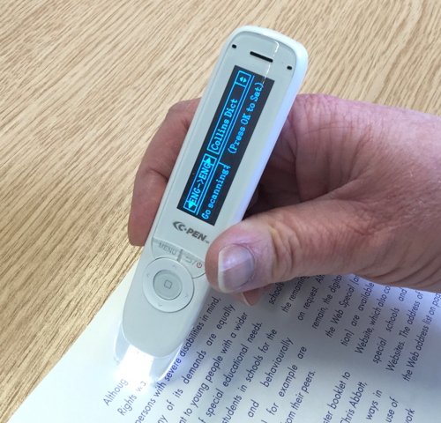
Normal Pen – dictionary function is Exam Pen – dictionary function is
enabled disabled

Laptops

We also have the facility for students to use laptops in the classroom. Again, these are available to students across all year groups and these can be used for a variety of reasons. This ranges from a student who has difficulties in handwriting and work speed but is able to type more effectively, to students having an injury that prevents them from writing. These are held in our Learning Support room together with the scanning pens. Students are able to access these throughout the school day.

Whilst we know that sometimes accidents happen, if your child is identified as needing to have a laptop for all lessons, we will send home our Home Agreement for your approval and signature. This is in case the laptop gets damaged in anyway whilst this is in your child’s possession. If this should happen, we will of course contact you to discuss this.

Ear Defenders

Some of our students have sensitivity to loud noise, certain sounds and acoustics in some of our classrooms. For these students, we do hold ear defenders that are used in these circumstances to help the student desensitise from the noise and to focus easier on their learning.

Above are the types of ear defenders and ear plugs that we have available in school.

Frequently Asked Questions

There is always so much to consider when your child is starting Secondary school.
Below are just some of our frequently asked questions. We hope these will be of help to you.

Q: What transition package do you offer for children with SEND?

A: We currently offer extra transition visits at the end of the school day. These can be arranged via our SEND department. All of our new Year 7 cohort will have two full days with us in July, where they will get to experience JSTC during active school times.

Q: Who provides extra support for students with SEND?

A: Our SEND Department and our dedicated team of LSAs are always on hand to provide support for all of our students across all year groups. This includes in class support and interventions in small groups or on a 1:1 basis

Q: Are all staff trained in working with children with SEND?

A: Yes. All staff are trained in this area and are regularly asked to attend courses or webinars to continue with their personal professional development.

Q: Are staff familiar with EHCPs?

A: Yes. Both teaching staff and LSAs are familiar with EHCPs and are aware of their importance for the student it relates to. Staff are advised to familiarise themselves with information from the EHCP to ensure that the student is supported in the correct way.

Q: Will my child have a dedicated LSA (Learning Support Assistant) or will he/she/they have shared support?

A: Most of our LSA support is in a shared capacity. 1:1 LSA support is based on the needs of the student and details of the EHCp if they have one. Our aim to ensure that we provide the independence your child needs to leave us, aged 16, as a young adult.

Q: Will my child have access to LSAs with specialist subject knowledge?

A: We endeavour to distribute our LSA team to their specialist areas. However, sometimes it is not always possible for us to do this.

Useful Links

Below we have listed some links that will hopefully help you to make the right
decision, together with your child, for their secondary education placement.

https://www.jstc.org.uk/send (JSTC SEND Policy)

https://www.lincspcf.org.uk (Lincolnshire Parent Carer Forum)

https://www.lincolnshire.gov.uk/send-local-offer (SEND Local Offer)

https://www.nationwideschooluniforms.co.uk (Uniform Supplier)

Moving Forward

We are looking forward to meeting our new cohort of students in September. If you have any further questions or queries in relation to this booklet, please do not hesitate to contact our SEND Department via email at send@jstc.org.uk.

