JOHN SPENDLUFFE

TECHNOLOGY COLLEGE



LOCKDOWN POLICY

Approved by: Full Governing Body | Date: September 2026
Last reviewed in: August 2026
Next review due by: September 2027

- Introduction and context
This policy is intended to ensure that students and staff are safe in situations where there is a threat in the school grounds or outside the school that requires students and staff to be locked within buildings for their own safety. This policy must be used in conjunction with the JSTC Critical Incident Policy. Staff will be briefed of the Lockdown procedures on staff training days and a drill will be held annually.

- Scope
This policy applies to employees, volunteers, parents/carers, students, and people visiting the school site. It covers the procedures and personnel responsible when the school is required to go into lockdown.

- Guidelines
  - Lockdown Guidelines

The JSTC Lockdown Policy applies when students and staff need to be locked within buildings for their own safety. There are 2 kinds of Lockdown:

- Partial Lockdown – An incident in or around the local area with the potential to become a threat to safety of persons on JSTC site leading to Full Lockdown. For example:
  - A reported incident or civil disturbance in the local community which potentially poses a risk to the school community
  - A warning being received regarding a local risk of air pollution (e.g. smoke plume, gas cloud)
  - A dangerous individual in the locality.
  - A major fire in the local area of the school.
  - The close proximity of a dangerous animal roaming loose.
  - Serious accident on-site requiring good access for emergency services.

- Full Lockdown – An incident with immediate threat to the safety of persons on JSTC site.
  - An intruder on the school site with the potential to harm students, staff and visitors.
  - An escalation of any of the Partial Lockdown incidents to immediate threat

Copies of this policy will be disseminated via the Shared Documents area and a hard copy available in staffroom. Classrooms will also have a prompt document to support in an emergency situation.

  - Testing of the policy

Site Manager or a member of Senior Leadership Team (SLT) designated by the Headteacher, will schedule at least one practice lockdown drill per year and will be responsible to ensure all staff members are clear about the procedure before the practice drill takes place. Progress Teams will remind students of the lockdown procedure through assemblies or during tutor time.

  - Communicating with the media

Most important to seek advice from Local Education Authority (LEA) before agreeing to speak to or be interviewed by the media. If this is not an option then an agreed text for release should be prepared by the Critical Incident Management Team (CIMT) and a designated spokesperson briefed and prepared to respond on the school’s behalf. This should be Headteacher or Deputy Headteachers all other staff should not comment to any outside agency beyond the Emergency Services.

- Lockdown procedure
In the event of an emergency, the Headteacher or Deputy Headteacher (or the most Senior Assistant Headteacher if the Head and Deputy are not available) will make the decision, in consultation with the police when deemed necessary, with regard to whether the school needs to be partially locked down or fully locked down.
Contact Numbers:
- Police/Emergency Services – 999 - Main Control Room
- Local Education Authority – LCC – 01522 552222
- Local Council Authority – East Lindsey District Council – 01507 601111
Once the decision has been made the Critical Incident Management Team (CIMT) will be assembled (this is likely to be via phone/email/walkie talkie), this team will be made up of the following people:
CIMT
Headteacher Authorise & Manage Lockdown as Lead Person
Deputy Head Assist Headteacher or Assume Lead Roll in Headteacher Absence
Members of SLT Roles designated by Lead dependant on situation
Premises Manager Site Security & CCTV Monitoring
Admin Team Switch Phones to Answer Message
Attendance Team Collate Headcount Information
IT Team Upload Statements to Bromcom/Website & Issue Text Round
Chair of Governors External Liaison

In the event of any lockdown being implemented the designated person in charge will ensure that once the emergency services have been made aware, the LEA are immediately informed of the situation.

- Partial lockdown
Partial lockdown should be seen as a precautionary measure which puts the school in a state of readiness should a situation escalate, whilst retaining a degree of normality.

  - Alert - Alert to all staff: “Partial lockdown”

This may be as a result of a reported incident or civil disturbance in the local community with the potential to pose a risk to students, staff and visitors in the school. It may also be as a result of a warning being received regarding the risk of air pollution, etc.

  - Immediate action

- Inform Staff of Partial Lockdown using Email, 2 Way Radios, Internal Telephones, Loud Hailer or Word Of Mouth. No alarm will sound for Partial Lockdown
- All outdoor activity to cease immediately with students and staff returning indoors.
- If incident occurs during Break, Lunch or on arrival to site then the Loud Hailer will be used
- All students and staff to remain indoors and external doors and windows locked.
- Take a Headcount & Email to Headcount@jstc.org.uk highlighting anyone missing
- Free movement may be permitted within the building, dependent upon the circumstances.

All situations are different; once all students and staff are safely indoors, CIMT will conduct an ongoing assessment based on advice from the Emergency Services. This assessment will then be communicated to staff, who can inform students.

In the event of an air pollution issue, air vents can be closed where this is possible. Emergency Services will advise as to the best course of action in respect of the prevailing threat.

- Full lockdown
This signifies an immediate threat to the school and may be an escalation of a partial lockdown (for example when an intruder is within the school grounds).

  - Alert - Alert to staff: “Full lockdown”

  - Immediate action

- All Staff & Students to head immediately to safe rooms.
  - Before school, break & lunch time – Tutor Rooms.
  - During Lessons – Stay in teaching rooms. PE/Outside lessons to nearest safe room – Changing rooms, Sports Hall. If not possible then hide out of view.
  - End of School as leaving – To nearest safe place either onto awaiting buses or back into school and to tutor rooms.
- External doors locked (main building double door to remain unlocked to provide exit route if needed)
- Classroom doors locked.
- Windows closed and where possible locked and blinds drawn.
- Students sit quietly out of sight (e.g. under desk or around a corner).
- Take a register & email the following information (in the layout/example stated below) to Lockdown@jstc.org.uk sharing names and highlighting anyone missing. All rooms have a lockdown procedure checklist near to the teachers desk to follow.
  - In EN3 with 7.4
  - No additional students˙
  - No missing students
  - Staff: Teacher A with Teacher B
  - Names must be included

Staff and students remain in lockdown until it has been lifted by the CIMT or the Emergency Services. At any point during the lockdown the situation may change and escalate resulting in the need for emergency evacuation procedures to be implemented. The move to an evacuation will be communicated by sounding of the fire alarm which will lead to a full evacuation to the muster point, whereby further instruction will be given.

During the lockdown, staff will keep agreed lines of communication open but not make unnecessary calls to CIMT, SLT or the office team as this could delay more important communication.

Specific Guidance for PE (outdoor lessons)
If in the Sports Hall, go to the gym. Teacher can then use the PC and telephone in the Drop-in office.
If at the Lower field (behind Sports Hall) go to the Humanities block/classroom. Teacher in this classroom is to send the information to the Lockdown email.
If at the Upper field (behind Maths/MFL) go to the Maths block/classroom. Teacher in this classroom is to send the information to the Lockdown email.
If on the Astroturf, go to the MFL block/classroom. Teacher in this classroom is to send the information to the Lockdown email.

  - Communication channels

For Full Lockdown switch incoming phone lines to answer phone with a pre-recorded message and no facility for messages to be left. Designate one separate phone line for communication with Emergency Services and/or LEA & Local Authority. (This number will be shared at initial point of contact)

During the lockdown, staff will keep agreed lines of communication open but not make unnecessary calls to CIMT, SLT, Attendance Team or the Admin Team as this could delay more important communication.

Agreed Lines of Communication – CIMT

- 2 Way Radio
- Internal Telephone
- Email
- Designated External Phone Line – For communication with Emergency Services
- Mobile Phones – Personal phones not school issue (Used at users discretion)
- Word Of Mouth

Teaching/Non-Teaching Staff

- Email
- Internal Telephone
- Text Round
- Word Of Mouth

- JSTC Full Lockdown procedure

Lockdown Procedure Management and Control
Nominated person | Responsibility
CIMT | Initial contact & liaison with the emergency services & manage incident
IT Manager via text round | Liaison with parents
All staff | Student supervision and control

Signals
Signal for Full lockdown | Audible alarm tone (different to Fire alarm), Email pop-up message, telephone
Signal for all-clear | Audible alarm tone (different to Fire alarm), Email pop-up message, telephone

Lockdown
Specified assembly room | Nearest assembly/safe room
Entrance points | *All external and internal School doors.
Communication arrangements | - Two-way radios  - Mobile phones  - Instant messaging/email  - Word of Mouth/verbal
Notes | *External doors to be locked by a member of staff in each of the individual blocks as per site plan in the appendix. Once these are locked internal classroom doors to be locked. Main building double doors (next to girls toilets) to be open to provide exit route if needed.

Lockdown Procedure
Step | Initial response | Check | Time | Signed
1 | Ensure all students are inside the specified assembly room or closest safe space.
2 | Secure all entrance points to the specified assembly room.  - External doors  - Fire doors  - Internal doors  - All windows  - Air vents (in the case of fire or air pollution)

3 | A member of the CIMT will Dial 999 for each emergency service that the incident requires.
4 | Staff members who are not teaching at the start of lockdown should go to the nearest assembly room/safe space. If a room is ‘visually open’ (i.e the humanities invention room) go to the closest classroom if safe to do so.
5 | Ensure that staff members take action to increase protection from further danger:  - Block access points.  - Sit on the floor, under tables or against the wall.  - Keep out of sight and draw curtains to avoid detection.  - Turn off lights.  - Stay away from windows and doors.  - Students to turn off all mobile phones and electronic devices.  - Await further instruction.
6 | Ensure that all students and staff members inside the specified assembly room are aware of an exit point in case an intruder manages to gain access, or the assembly room becomes unsafe.
7 | Ensure that students who are outside the School buildings are brought inside as quickly as possible, unless this endangers them and others. If students remain outside direct them to hide behind a safe spot out of view.
8 | Take a register of persons within the specified assembly room with the information highlighted above. Send to Lockdown@jstc.org.uk
9 | Check for missing or injured staff members and students if it is safe to do so.
10 | Remain inside the specified assembly room until the all clear signal has been given or unless told to evacuate by the emergency services. (If it escalates to a full evacuation this will be the Fire Alarm tone).
11 | If someone is taken hostage on the premises, the school should seek to evacuate the rest of the site under guidance from the emergency services.

To remain unlocked as an escape route.
- Emergency services
It is important to keep lines of communication open with Emergency Services as they are best placed to offer advice as a situation unfolds. The school site may or may not be cordoned off by Emergency Services dependent upon the severity of the incident that has triggered the lockdown. Emergency Services will support the decision of the Headteacher with regarding the timing of communication to parents.
Given the nature and layout of the JSTC site with access & egress via one road the Headteacher or designated person would insist that the road is secured at the entrance to Caroline Street to prevent unnecessary access and allow free access & egress for emergency services.

In the event of a prolonged lockdown or more severe scenario it may be appropriate to liaise with the emergency services to arrange a Reception Centre for family members outside of the cordoned off area. This would be subject to the discretion of the Emergency Services. JSTC staff by nature of the situation would be unable to man any reception centre. Potential Sites for a Reception Centre:

- Alford Manor House
- Alford Corn Exchange

Location of any Reception Centre would be the decision of the Emergency Services based on situation in the wider locality and threat levels perceived.

- Communication with parents and carers
School lockdown procedures, especially arrangements for communicating with parents and carers, should be routinely shared with parents and carers, although it is not advisable to share entire lockdown plans. In the event of an actual lockdown, it is strongly advised that any incident or development is communicated to parents and carers as soon as is possible. Parents and carers will obviously be concerned but regular communication of accurate information will help to alleviate undue anxiety.

  - Information to share with parents and carers

Parents and carers should be given enough information about what will happen so that they:

- are reassured that the school understands their concern for their child’s welfare, and that it is doing everything possible to ensure their child’s safety
- do not need to contact the school as calling the school could tie up telephone lines that are
needed for contacting emergency service providers,
- do not come to the school as they could interfere with access by emergency service providers and may even put themselves and others in danger,
- wait for the school to contact them about when it is safe to come to collect their children, and
where this will be from.

These communications should be in the form of pre-determined text that can be uploaded to Bromcom, JSTC Website, Text round service & Official Social Media Platforms.

This part of the plan must reassure parents and carers that the school understands their concern for their children’s welfare and that everything that can possibly be done to ensure children’s safety will be done. However, it may also be prudent to reinforce the message “…the school is in a full lockdown situation. During this period the switchboard and entrances will not be staffed, external doors locked and nobody will be allowed in or out…”

It is also recommended that any drill or practice is communicated to parents/carers to ensure unnecessary anxiety or panic is not caused. This can be done using the same methods listed above.

- JSTC School lockdown plan

Person(s) with authority to manage the lockdown
Simon Curtis | Headteacher
Rachael Norton | Deputy Head
Anna Appleyard | Deputy Head
Robert Thornalley | Senior Assistant Headteacher, DSL
Mark Bishell | Premises Manager
Jon Treasure, Susie Powell, Katy Startin, Lizzie Arrowsmith | SLT
Liz Ramm | Chair of Governors
Circumstances where lockdown will be applied:

- A reported incident or civil disturbance in the local community which potentially poses a risk to the school community.
- A dangerous individual in the locality.
- An intruder on the school site with the potential to pose a risk to students, staff and visitors.
- A warning being received regarding a local risk of air pollution (e.g. smoke plume, gas cloud).
- A major fire in the local area
- The close proximity of a dangerous animal roaming loose.
- Serious accident on-site requiring good access for emergency services.

Implementation of Lockdown procedure
Identification of circumstances requiring a lockdown within JSTC site (i.e. Intruder). Information received from external sources regarding a possible risk to JSTC staff, students, visitors, contractors etc. (i.e. Pollution smoke/gas, local disturbance).

Arrangements for how the lockdown signal will be given
Audible Alarm, pop-up email message to staff computers, telephone, word of mouth
Guidance on where people go if they are outside or away from the classroom
Students who are outside the School buildings are brought inside as quickly as possible, unless this endangers them and others. If students remain outside direct them to hide behind a safe spot out of view.

Details of how a headcount will be undertaken
Staff within the locked down room will take a headcount of all students and staff present highlighting any missing persons.

Example of information to be shared:
  - In EN3 with 7.4
  - No additional students
  - No missing students
  - Staff: Miss Le’Gate and Miss Vickers

This should then be emailed to to Lockdown@jstc.org.uk for collation. The Attendance Team and Admin Team should chase up any missing information from rooms. Any persons identified as missing, a member of the CIMT will be notified for action to be taken/considered.
If a full evacuation is required a further roll call will be taken at the muster point.

How the plan will be shared, tested and reviewed
Via school training days, shared documents area, hard copy displayed in staffroom. Annual Lockdown drill and a review of the drill and the plan for effectiveness.
Training requirements for staff and students
Staff to be fully trained in the Lockdown procedure, roles, responsibilities and communication strategy.
Students to be made fully aware of the Lockdown procedure prior to a full drill, this will be done through assemblies and tutor time.

Debriefing arrangements following a lockdown
An experienced person, possibly from outside the school community, should lead a debrief meeting to:
Clarify what has happened
Allow for sharing of reactions
Reassure people that reactions are normal
Mobilise resources e.g. support groups for staff, students and parent/carers

- Lockdown situations when away from the school
The school will also plan for what would happen if a lockdown situation should arise when a group is away from school, whether this be on a short visit, day trip or longer trip that involves a party staying away, possibly even in a foreign country.

The school will always carry out a risk assessment prior to such visits and will consider what would happen if an emergency situation arose that was out of the control of the staff who are supervising the students on the trip.

This will include requesting a copy of the receiving organization or establishments Lockdown Policy, procedures & protocols.

Appropriate guidance will be given to students prior to the trip and will be reinforced during the trip itself. Parents and carers will also be provided with information about the procedures that would be followed.

It is almost impossible to predict the circumstances where an emergency situation might arise in a way that specific planning can be undertaken. As a minimum it will be prudent to show students an emergency meeting point if the party gets separated and remind them to follow instructions from the Emergency Services. If the trip involves staying in a hotel or hostel the staff leading the trip should identify areas of the building where they are most likely to be able to protect the children in their care. Students will be asked to disperse or hide if this will aid their safety.

If a group is away from site on a trip then the staff responsible should be contacted and informed of the situation and told to stay away or to go to a place designated by the Emergency Services.

If staff have left site for any reason and are expected to come back they also need to be informed of the situation so they too are told to stay away or go to a place designated by the Emergency Services.

- Appendices

The following Appendices include excerpts from the JSTC Critical Incident Policy which refer to conditions that would be active during a potential lockdown.

- Appendix 1 – Organisational Flow Chart
- Appendix 2 – Bomb Hoaxes
- Appendix 3 – Evacuation
- Appendix 4 – Lockdown
- Appendix 5 – Bomb Threats
- Appendix 6 – Suspicious Packages

APPENDIX 1 – ORGANISATIONAL FLOW CHART
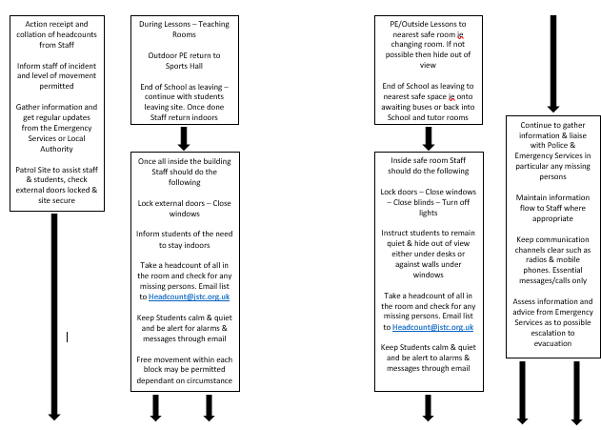
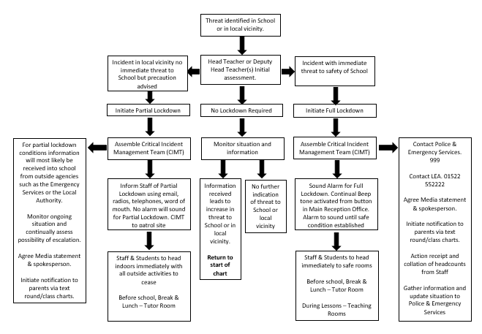
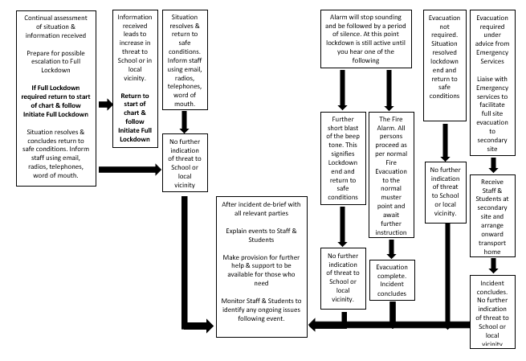

APPENDIX 2 – BOMB HOAXES

Template letter to parents/carers regarding bomb hoaxes
Dear Parent /Carer

Following recent hoax bomb calls to academies across the UK this letter is to provide an update to students, their parents and carers.

Some of the calls are linked to each other and others are ‘copycat’ calls. Each call has caused significant disruption to school life, upset to school staff and concern to students, their parents and carers.

The police treat calls threatening bomb attacks very seriously and are committed to working with schools and local councils to ensure the safety of all students and to minimise disruption to their learning. They have taken the following action:

- Every bomb threat is assessed. Highly experienced officers review intelligence and work with counter- terrorism experts, who have an in depth knowledge of these incidents, to quickly assess whether a threat is real or not. So far, there is no credible threat posed to student safety and all the calls have been malicious designed to cause fear and disruption.
- Police have begun a major criminal investigation. Making a hoax bomb threat is a serious crime punishable by up to seven years imprisonment. Police forces across the country are working together to find those responsible and a number of arrests have already been made.
- Police and the Department for Education have shared guidance on what to do in the event of a bomb threat with leaders of schools, other education establishments, and authorities. This guidance also signposts to advice on wider security reviews and enhances existing safety and security plans held by schools which are well-rehearsed and designed to manage a range of situations. Public guidance on how you, schools and the council can prepare for emergencies is here: www.gov.uk/local-planning-emergency- major-incident.

As a parent or carer, we understand your concerns. There is a real threat from terrorism and it is important that we are alert but not alarmed. Schools remain some of the safest and most secure public spaces. Their staff are highly-trained and the wellbeing of students is their top priority.

To help us we ask the following from you:

- If you have specific questions about your school’s safety plans or site security, speak to school staff.
- If your school makes a decision to temporarily suspend lessons while safety checks are carried out, do not attend to remove your child unless asked to do so. Do not phone the emergency services to ask for updates on your child as it delays genuine people in need from getting help. Schools will keep you informed and always arrange care for students unable to return home or whose parents/carers are unable to collect them.
- Do not attend and remove your child from a school that has not been affected by an alert as it results in missed learning opportunities.
- Speak to your child about the consequences of making hoax calls. What may appear as a ‘joke’ now may result in a police record and have long-lasting implications on their future.

If you have any information about those responsible for the security alerts call police on 101 (999 in an emergency) or the independent charity CrimeStoppers anonymously on 0800 555 111.

APPENDIX 3 - EVACUATION

Signals
Signal for fire evacuation | Fire Alarm
Signal for bomb evacuation | Fire Alarm followed by message to staff
Signal for all-clear | Loud Hailer – Message Delivered at Muster Point

Assembly points - fire evacuation
Fire evacuation assembly point A | School Field
Fire evacuation assembly point B | Alford Primary School

Assembly points - bomb evacuation
Bomb evacuation assembly point A | School Field
Bomb evacuation assembly point B | Alford Primary School

If the school has been evacuated and pupils are not able to return to school (or go home) it may be possible to relocate temporarily to another building (e.g. buddy school or place of safety).

Pre-identified buddy school / place of safety / rest centre
Name of premise | Alford Primary School
Type of premise | School
Contact name | Mrs Laura Mackenzie-Snow - Headteacher
Address | Hanby Lane Alford
Directions / map | Opposite John Spendluffe
Estimated travel time  (walking, with pupils) | 5 minutes

APPENDIX 4 - LOCKDOWN

Signals
Signal for Lockdown | Continual Beep Tone Through Fire Alarm System – Email to All Staff. Tone Will Continue Until Safe Condition Established
Signal for Lockdown Leading to Evacuation | Period of Silence After Continual Beep Tone Followed by Normal Fire Alarm to Signal Evacuation Required
Signal for Lockdown Lifted | Period of Silence After Continual Beep Tone Followed by A Short Burst Of Continual Beep Tone – Email to All Staff

Lockdown
Rooms most suitable for lockdown | All blocks lockable
Entrance points (e.g. doors, windows) which should be secured | All blocks have lockable exists and entry
Communication arrangements | - Two-way radios  - Classroom telephones  - Mobile phones  - Instant messaging / email as appropriate
Notes | Details of Reason for Lockdown will be shared with Staff where appropriate once Lockdown is over and Safe Condition established

Upon hearing the lockdown signal, take the action below. If someone is taken hostage on the premises, the school should seek to evacuate the rest of the site.

Ref’ | Initial response - lockdown | Tick / sign / time
L1 | Ensure all pupils are inside the school building. Alternatively, ask pupils to hide or disperse if this will improve their safety.
L2 | Lock / secure entrance points (e.g. doors, windows) to prevent the intruder entering the building.
L3 | Dial 999. Dial once for each emergency service that you require.
L4 | Ensure people take action to increase protection from attack:  - Block access points (e.g. move furniture to obstruct doorways)  - Sit on the floor, under tables or against a wall  - Keep out of sight  - Draw curtains / blinds  - Turn off lights  - Stay away from windows and doors.
L5 | Ensure that pupils, staff and visitors are aware of an exit point in case the intruder does manage to gain access.
L6 | If possible, check for missing / injured pupils, staff and visitors.
L7 | Remain inside until an all-clear has been given, or unless told to evacuate by the emergency services.

APPENDIX 5 - BOMB THREATS

- If you receive a telephone call from someone who claims to have information about a bomb, record as much information as possible.

Time of call:

Telephone number you were contacted on:

Exact wording of the threat:

- Stay calm. Being cautious, and without provoking the caller, try to ask the questions below.

Where is the bomb right now?

When will it explode?

What does it look like?

What kind of bomb is it?

What will cause it to explode?

Did you place the bomb? If so, why?

What is your name?

What is your telephone number?

What is your address?

- Try dialling 1471. You may get information on where the phone call was made from.

Did dialling 1471 work?

Time the call ended:

- Contact the Police (999) and Headteacher / Deputy Headteacher immediately.

- Carry out further actions based on Police advice.

What gender was the caller?
- Male
- Female

Approximately how old was the caller?

Did the caller use a codeword?

Did the caller have an accent?

Did the caller sound familiar?

What sort of voice did the caller have?

- Normal
- Loud
- Quiet
- Whispered
- Clear
- Disguised
- Well spoken
- Poorly spoken
- Deep
- High pitched
- Hoarse
- Nasal
- Impediment
- Stutter
- Lisp
- Slurred
- Other

At what pace did the caller speak?

- Normal
- Quick
- Slow

What manner did the caller have?

- Normal
- Calm
- Excited
- Laughing
- Upset
- Angry
- Rational
- Irrational
- Irritated
- Muddled
- Other

Were there any distinguishable background noises?

Notes:

APPENDIX 6 - SUSPICIOUS PACKAGES

Postal bombs or biological / chemical packages might display any of the following signs:
- Excessive wrapping
- Grease marks or oily stains on the envelope / wrapping
- An unusual odour including (but not restricted to) ammonia, almonds or marzipan
- Discolouration, crystals or powder-like residue on the envelope / wrapping
- Visible wiring / tin foil
- Heavy weight for the size of the package
- Uneven weight distribution
- Too many stamps for the weight of the package
- Poor hand writing, spelling or typing
- Delivery by hand from an unknown source
- Wrongly addressed or come from an unexpected / unusual source
- No return address or a postmark that does not match the return address.

The likelihood of a school receiving a postal bomb or biological / chemical package is low. However, if you do receive a suspicious package carry out the actions below.

Ref’ | Initial response - upon receiving a suspicious package | Tick / sign / time
SP1 | Remain calm.
SP2 | Put the letter / package down gently and walk away from it:  - Do not touch the package further  - Do not move it to another location  - Do not put the package into anything (including water)  - Do not put anything on top of it.
SP3 | Note its exact location.
SP4 | Evacuate the building, keeping people away from the room as far as possible. Ensure that any assembly points are located away from the danger of flying glass.
SP5 | Notify the Police (999) and the Headteacher / nominated emergency contact immediately.
SP6 | Do not use mobile phones, two-way radios or sound the alarm using the break glass call points.

If anyone is exposed to a potentially hazardous substance carry out the actions below.

Ref’ | Initial response - if exposed to a potentially hazardous substance | Tick / sign / time
SP7 | Keep all persons exposed to the material separate from others, and available for medical examination. Ask them to remain calm and avoid touching their eyes, nose or any other part of their body.
SP8 | Ensure that ventilation / air circulation systems in the building have been turned off and that all doors (including internal fire doors) and windows have been closed.
SP9 | Anyone experiencing symptoms of chemical exposure (e.g. streaming eyes, coughs and irritated skin) should seek medical attention urgently.

POLICY DOCUMENTS

The following policy document was presented to the Governing Body of John Spendluffe Technology College and approved and adopted by them on the date stated.

Policy: Lockdown

Approved on behalf of the Governing Body.

Mr S Curtis, Headteacher

