JOHN SPENDLUFFE

TECHNOLOGY COLLEGE

Early Career Teacher (ECT) Policy

Approved by: | Full Governing Body | Date: September 2023
Last reviewed on: | July 2023
Next review due by: | September 2024
Aims
The school aims to:
- Run an ECT induction programme that meets all the statutory requirements underpinned by the early career framework (ECF)
- Provide ECTs with a supportive environment that develops them and equips them with the tools to be effective and successful teachers.
- Make sure all staff understand their role in the ECT induction programme.

Legislation, Statutory guidance and Supporting Materials
This policy is based on:
- The Department for Education’s (DfE’s) statutory guidance Induction for early career teachers (England) from April 2023
- The Early career framework reforms
- The Education (Induction Arrangements for School Teachers) (England) Regulations 2012
- The ‘relevant standards’ referred to below are the Teachers’ Standards.
- Education Development Trust: Early Career PDP: Curriculum Overview
- LEAD Teaching School Hub Guidance: https://www.leadtshublincs.co.uk/

The Early Career Professional Development Programme (ECPDP)
The ECPDP is underpinned by the Early Career Framework (ECF), enabling ECTs to understand and apply the knowledge and skills set out in the ECF.
The ECPDP is a 2-year support, ECF-based, induction programme, designed to act as a bridge between initial teacher training and a career in teaching. It combines a structured programme of development, support, and professional dialogue, with monitoring and an assessment of performance against the Teachers’ Standards. The programme supports the ECT and provides them with the necessary training to ensure that they can demonstrate that their performance against the Teachers’ Standards is satisfactory by the end of the period. This induction should provide a foundation for ECTs and equip them with the tools to be an effective and successful teacher.
The ECPDP for JSTC is being delivered by the Lead Provider, the Education Development Trust (EDT), supported and coordinated by our Appropriate Body (and delivery partner), L.E.A.D. Teaching School Hub (LEADTSH), whose role is the quality assurance in the ECT induction, including ensuring the ECT’s receive their statutory entitlements and that support, assessment and guidance procedures in place are fair and appropriate.
For a full-time ECT, the induction period will typically last for 2 academic years. Part-time ECTs will serve a full-time equivalent. Up to one term of continuous employment may count towards completion of the induction period.
The ECPDP is quality assured by LEADTSH, our ‘Appropriate Body’.
Posts for induction
Each ECT will:
- Be provided with the necessary employment tasks, experience, and support to enable them to demonstrate satisfactory performance against the relevant standards throughout, and by the end of, the induction period.
- Have an appointed induction tutor, who will have qualified teacher status (QTS).
- Have an appointed induction mentor, who will have QTS.
- Have a reduced timetable to allow them to undertake activities in their induction programme; in their first year, this will be no more than 90% of the timetable of our existing teachers on the main pay range, and in their second year, this will be no more than 95% of the timetable of our existing teachers on the main pay range.
- Regularly teach the same class or classes.
- Take part in similar planning, teaching and assessment processes to other teachers working in similar posts.
- Not be given additional non-teaching responsibilities without appropriate preparation and support.
- Not have unreasonable demands made upon them.
- Not normally teach outside the age range and/or subjects they have been employed to teach.
- Not be presented with unreasonably demanding pupil discipline problems on a day-to-day basis.
Support for ECTs
JSTC support ECTs with:
- A designated induction tutor, who will provide monitoring and support, and co-ordinate their assessments.
- A designated induction mentor, who will provide regular structured mentoring sessions and targeted feedback
- Observations of their teaching at regular intervals, and follow-up discussions with prompt and constructive feedback.
- Regular professional reviews of their progress, to take place termly (except in terms where formal assessment is held), at which their induction tutor will review objectives and revise them in relation to the relevant standards and their current needs and strengths.
- Chances to observe experienced teachers, either within the school or at another school with effective practice.
Assessments of ECT performance
Formal assessment meetings will take place in the final term of the ECT’s first year (term 3) and the final term of their second year (term 6) and will be carried out by the Induction tutor.
These meetings will be informed by clear and transparent evidence gathered from progress reviews during the preceding assessment period and drawn from the ECT’s work as a teacher and from their induction programme. Copies of the evidence relied on will be provided to the ECT and the appropriate body.
After each formal assessment meeting, a formal assessment report will be completed that clearly shows how the ECT is performing against the relevant standards. The headteacher will also recommend to the appropriate body in the final assessment report at the end of the programme as to whether the ECT’s performance is satisfactory against the relevant standards.
The ECT will add their own comments, and the formal assessment report will be signed by the headteacher, induction tutor and the ECT.
A copy of the formal assessment report will then be sent to the appropriate body. The final assessment report will be sent within 10 working days of the meeting, for the appropriate body to make the final decision on whether the ECT has passed their induction period.
If the ECT leaves this post after completing one term or more but before the next formal assessment would take place, the induction tutor or headteacher should complete an interim assessment to ensure that the ECT’s progress and performance since the last assessment is captured.
At-risk procedures
If it becomes clear during a termly progress review or at the first formal assessment point that the ECT is not making sufficient progress, additional monitoring and support measures will be put in place immediately, meaning:
- Areas in which improvement is needed are identified.
- Appropriate objectives are set to guide the ECT towards satisfactory performance against the relevant standards.
- An effective support programme is put in place to help the ECT improve their performance.
The progress review record or formal assessment report will be shared with the appropriate body, alongside the support plan, for it to review.
If there are concerns about the ECT’s progress during their subsequent progress reviews or formal assessment, if it is not the final formal assessment, the induction tutor or headteacher will discuss this with the ECT, updating objectives as necessary and revising the support plan for the next assessment period.

Roles and responsibilities
The ECT
The ECT will:
- Provide evidence that they have QTS and are eligible to start induction.
- Meet with their induction tutor at the start of the programme to discuss and agree priorities and keep these under review.
- Agree with their induction tutor how best to use their reduced timetable allowance and guarantee engagement with the ECPDP.
- Provide evidence of their progress against the relevant standards.
- Participate fully in the monitoring and development programme.
- Participate in scheduled classroom observations, progress reviews and formal assessment meetings.
- Agree with their induction tutor the start and end dates of the induction period, and the dates of any absences from work during the period.
- Keep copies of all assessment reports.
When the ECT has any concerns, they will:
- Raise these with their induction tutor as soon as they can.
- Consult with their contact at the appropriate body at an early stage if there are difficulties in resolving issues with their induction tutor or within the school.
The Headteacher
The headteacher will:
- Check that the ECT has been awarded QTS and whether they need to serve an induction period.
- Agree, in advance of the ECT starting, who will act as the appropriate body.
- Notify the appropriate body when an ECT is taking up a post and undertaking induction.
- Make sure the ECT’s post is suitable according to statutory guidance.
- Make sure the induction tutor is appropriately trained and has sufficient time to carry out their role effectively.
- Make sure the induction mentor is appropriately trained and has sufficient time to carry out their role effectively.
- Make sure an appropriate ECF-based induction programme is in place.
- Make sure the ECT’s progress is reviewed regularly, including through observations and feedback of their teaching.
- Make sure that formal assessments are carried out and reports completed and sent to the appropriate body.
- Maintain and keep accurate records of employment that will count towards the induction period.
- Make sure that all monitoring and record keeping is done in the least burdensome and most streamlined way.
- Make the governing board aware of the support arrangements in place for the ECT.
- Make a recommendation to the appropriate body on whether the ECT’s performance against the relevant standards is satisfactory.
- Participate in the appropriate body’s quality assurance procedures of the induction programmes.
- Keep all relevant documentation, evidence and forms on file for 6 years.
The Induction Tutor
The Induction tutor has overall responsibility for ensuring ECTs successfully complete the statutory two school year period of induction. Their role includes:
- Facilitating a programme of support and developmental opportunities which is underpinned by the ECF, both via the Appropriate Body, the Lead Provider and within school.
- Ensuring that each department allocates an individual and appropriate Mentor.
- Supporting Mentors as to ensure each ECT enjoys consistent, high-quality provision throughout the year, and ensuring that any concerns about a ECT’s progress is picked up on early and that appropriate support is put in place.
- Making sure that the ECT’s teaching is observed, and feedback is provided. If the observer is not the Induction tutor a debrief should be provided to the relevant Mentor and Induction Tutor.
- Ensuring that 2 formal assessments points are completed, coordinating input from other colleagues as appropriate, and submitted to the Appropriate Body by the agreed deadline.
- Inform the ECT during the formal assessment meeting of the judgements to be recorded on their formal assessment record and invite the ECT to add their own comments.
- Making rigorous and fair judgements about the ECT’s progress in relation to the Teachers’ Standards.
- Conducting Progress Reviews to monitor progress in each term where a formal assessment does not take place.
- Informing the ECT, following progress reviews, of their progress against the relevant standards, and share records with the ECT, headteacher and relevant body.
- Ensuring that where an ECT is not satisfactorily meeting the Teachers’ Standards appropriate support is put in place and all relevant parties have been notified of any necessary measures.
- Making sure the ECT is aware of how they can raise concerns about their induction programme or their personal progress, both within and outside of the school
- Taking prompt, appropriate action if the ECT appears to be having difficulties.
- Making sure that all monitoring and record keeping is done in the least burdensome way, and that ECTs are not asked for any evidence that requires the creation of new work.
- Notify the appropriate body after each progress review as to whether the ECT is making satisfactory progress

The Induction Mentor
The Mentor monitors the progress of and provides day to day support for an ECT. They are expected to make rigorous and fair judgements about an ECT’s progress in relation to the Teachers’ Standards and provide effective coaching and mentoring throughout the induction period. The Mentor is to work closely with the Induction Tutor to create a holistic team around the ECT.
Their role includes:
- Meeting regularly with the ECT for structured mentor sessions to provide targeted feedback.
- Working with the ECT, and colleagues within the school who are involved in the ECT’s induction, to help make sure the ECT receives a high-quality ECF-based programme.
- Providing, or arranging, effective support – including subject-specific, phase-specific, coaching and/or mentoring
- Acting promptly and appropriately if the ECT appears to be having difficulties.
- Ensuring all relevant training materials for the ECPDP provided by the EDT have been read, understood and able to be confidently discussed with ECTs to provide expert support.
- Providing a personalised departmental programme of support.
- Engaging with Mentor training provided by the EDT, the LEADTSH.
Meeting between Mentors and the ECT
Meetings between Mentors and their ECTs will focus on developing knowledge and skills relating to the Teachers’ Standards, supported by the ECPDP, to include, but not limited to:
- Subject Knowledge development (including external examination processes).
- Teaching and Learning strategies and being judicious about what to implement when as to target the needs of different groups of learners and allow them to make progress.
- Classroom and Behaviour Management.
- Effective lesson planning for both sequences of lessons and individual lessons.
- Summative and Formative assessment.
- Personalising provision to meet the needs of various cohorts of learners.
- Effective use of the learning environment.
- Targeting individual professional development needs.
- Support with data tracking, collections, and analysis.
- Supporting with Parents Evening preparation.
The Governing Body
The governing body roles includes:
- Making sure the school complies with statutory guidance on ECT induction.
- Being satisfied that the school has the capacity to support the ECT.
- Making sure the headteacher is fulfilling their responsibility to meet the requirements of a suitable induction post.
- Investigating concerns raised by the ECT as part of the school’s grievance procedures.
- If it has any concerns or questions, seeking guidance from the appropriate body on the quality of the induction arrangements and the roles and responsibilities of staff involved in the process.
- If it wishes, requesting general reports on the progress of the ECT on a termly basis.

Links with other policies
This policy links to the following policies and procedures:
- Appraisal
- Grievance
- Pay
Appendix 1
Education Development Trust’s Early Career Professional Development Programme (ECPDP)
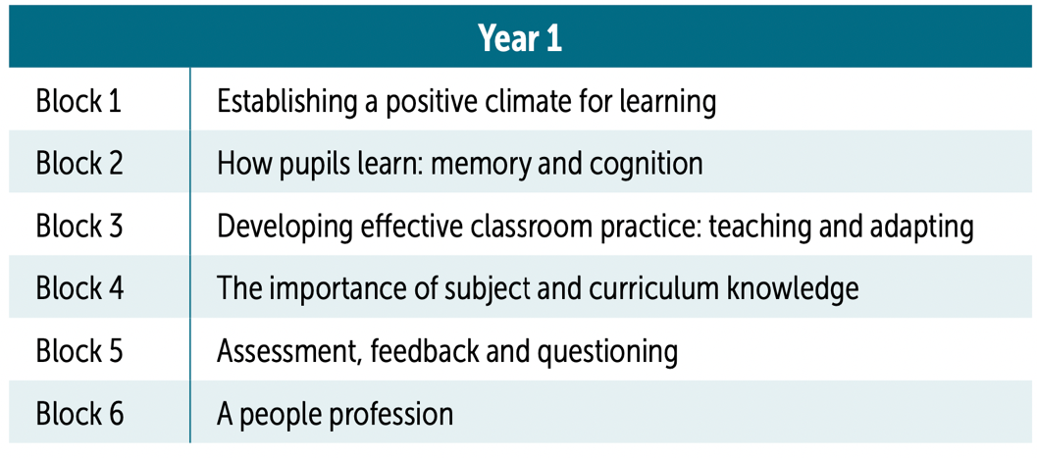
The EDT is a Lead Provider of that has designed a full induction programme, the ECPDP, which is accredited by the DFE and EEF.
The ECPDP is based around 6 blocks, in each year of the 2-year programme, with ECTs and their mentors working through 1 block per ‘half’ term.

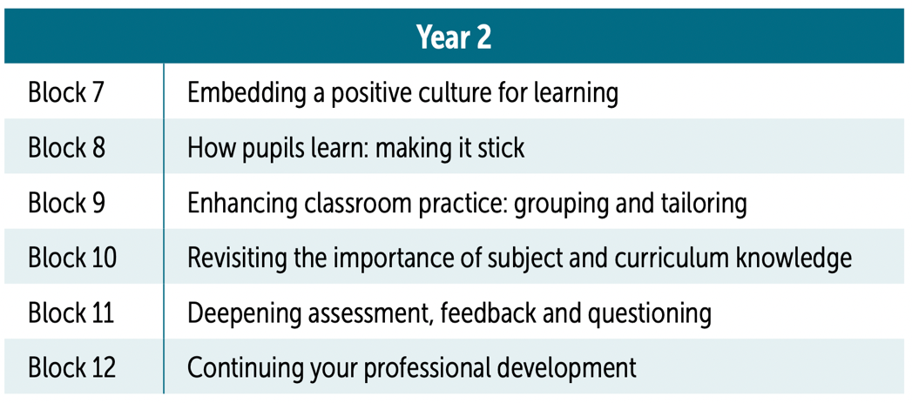

The term ‘block’ refers to EDT’s learning approach and delivery schedule, with every topic being covered by the three dimensions of development, just like a “block”. This supports ECTs to learn the theory, put the theory into practice, and reflect on personal and professional development.
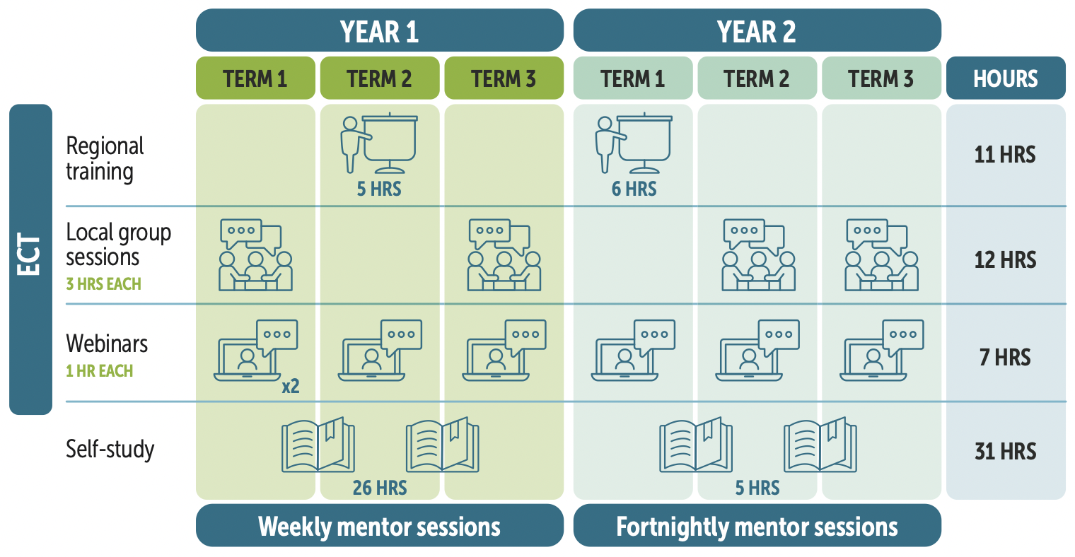
The ECPDP is delivered through blended learning, utilising an online platform, (giving access to self-study materials, videos, webinars, podcasts and blogs, and an easy way to select and book onto their training sessions), regional training, local group sessions and webinars, all delivered through the delivery partner, L.E.A.D. TSH.

POLICY DOCUMENTS

The following policy document was presented to the Governing Body of John
Spendluffe Technology College and approved and adopted by them on the date
stated.

Policy:

Headteacher: Mr S Curtis

Signed as approved on behalf of the Governing Body

See Appendix 1 – ECPDP framework

