JOHN SPENDLUFFE

TECHNOLOGY COLLEGE



CRITICAL INCIDENT
POLICY
Approved By – Full Governing Body | Date: 04/03/2026
Last Reviewed – 07/03/2026
Next Review Date – 16/03/2027

CRITICAL INCIDENT MANAGEMENT POLICY

Introduction

The handling of a crisis is a normal part of College life, but some incidents are of a critical, more overwhelming nature, and sadly in recent years incidents, previously deemed unthinkable, have occurred in Colleges in the UK.

This policy is our College’s contingency plan designed to provide a framework for handling a critical incident. The formulation of this policy is intended to clearly define the roles, responsibilities and procedures to follow, for College staff dealing with such an incident. Each critical incident is unique, and it is not possible to plan for every eventuality, but similarly each critical incident can be shocking and disorientating so a prepared procedure is essential to ensure that the College’s reaction is effective and efficient.
The details contained within this document will form the basis of the College’s approach to such a crisis.

Co-ordinated support will be available to the College from the LEA, and it will be practical to contact the LEA immediately.

If the incident involves the police, they will take control of certain management issues.

A Critical Incident Management Team will comprise the following staff:-

Headteacher
Deputy Headteacher(s)
Members of Leadership Team
Chair of Governors
Premises Manager

Individual roles & responsibilities will be delegated at the point of the incident. This will be done by the most senior leader on site that day. Allocating individual roles within the policy does not take into account possible staff absence or staff involvement in any incident.

Potential incidents that could affect John Spendluffe Technology College are considered to be: -

- Fire/flood
- Health risk – outbreak of contagious illness/disease like meningitis
- Major arson attack
- Fatal road traffic accident
- Serious injury on out of College visit
- Computer failure – e.g. risk of virus/hacker/parasite invasion from internet with additional implications for data protection
- Death of a pupil or member of staff
- Natural disaster within the community
- Consequences of terrorist or criminal activity
- Civil unrest within the locality
- Escaped/Dangerous Person/Animal in the locality
- Pollution or Chemical Release
- Hostile Intruder/Intruder on Site

For some of the incidents identified above it may be necessary to activate the Academy Lockdown protocol. Details of this can be found in the JSTC Lockdown Policy & Emergency Response Plan Document. Staff are issued with an overview sheet of key actions to carry out in the event of a Lockdown situation. JSTC carries out a drill of the Lockdown procedures at least once a year with records kept and any identified issues analysed and acted upon.

Appendix 1 contains an emergency contacts list – this will be reviewed annually and updated where necessary.

The College’s reaction to a critical incident can be divided into the following categories:

- Immediate action – Follow Emergency Response Plan Document
- Short term action
- Medium term action
- Longer term action

IMMEDIATE ACTION – Follow Emergency Response Plan Document

- Obtain and collate information relating to the incident – uncertainty breeds rumour and accurate information is essential;

- Gather and brief the CIMT (Critical Incident Management Team) – brief the team, allocate roles and responsibilities;

- Trigger support from the LEA and other contacts on emergency list – establish clearly who is going to contact whom;

- Set up an incident management room and dedicated phone line – to deal with calls from anxious parents etc. CIMT should agree a factual statement and avoid speculation;

- Contact families affected – must be done quickly and with sensitivity. Consistency of information is vital. It may be appropriate for families to come to College and immediate emotional support could be a possibility;

- Make arrangements to inform other parents – may need to take advice from LEA, especially if there is the possibility of legal liability. CIMT may wish to send a letter to parents, or prepare a leaflet.

- Inform teaching and other College staff – staff need to be cautioned about talking to the media or responding to questions from reporters. It is vital that all staff in contact with pupils are kept well informed and feel secure in handling comments or questions from pupils.

- Inform pupils – can be done in small or large groups depending on which is most appropriate. Care needs to be exercised to protect both children and adults closely involved in the incident. It is important that children receive a consistent account of the incident allowing for differences in their ability to understand.

- Encourage people involved to talk – the incident may need to be discussed before children go home for the day, for both pupils and adults.

- Deal with the media – most important to seek advice from County Office before agreeing to speak to or be interviewed by the media. If this is not an option then an agreed text for release should be prepared by the CIMT and a designated spokesperson briefed and prepared to respond on the College’s behalf.

- Devise a plan for handling the reactions and feelings of people affected – the most common reactions will include denial, distress, guilt, anger and helplessness. CIMT need to consider outside professionals to support and debrief staff and pupils affected by the incident. Those providing support also need support. At this point the CIMT will need to plan their short term reaction to the incident.

The Emergency Evacuation Point for JSTC is Alford Primary School, however, if emergency services issue an increased evacuation zone then it would be Alford Corn Exchange (Market Place, Alford). For Alford Primary School the evacuation zone would be the Church Hall, Alford.

SHORT TERM ACTION – the next stage

- Reunion of children with their families – especially where the incident occurs outside the College. Mostly children will need to be brought home, but sometimes parents and families need to visit the scene of the incident to understand how to deal with repercussions in terms of children’s fears etc.

- Managing staff – support needs organising for all staff, preferably from within the College, but using outside agencies if appropriate. Staff monitoring should be a priority, even members of the CIMT. If a crisis persists over many hours staff become tired, weary and upset and this affects their powers to make sensible decisions.

- Encourage pupils to talk – activate strategies for enabling young people to talk about the incident, and their feelings, using outside agencies if appropriate. Staff will need briefing about ways to help the children affected by the incident, and how to identify patterns of behaviour etc. This may have implications for the wider curriculum i.e. training in bereavement counselling for staff, provision of a range of books, Topic areas for house assemblies and tutor periods.

- Debriefing meeting – it may be appropriate to hold a debriefing meeting for staff, children and parents to:

  - clarify what has happened
  - allow for sharing reactions
  - reassure people that reactions are normal
  - mobilise resources e.g. parental support groups

An experienced person, possibly someone from outside the College community, should lead this meeting.

- Formal and informal recognition of rituals – it is important to remember to express sympathy to families of the hurt or bereaved. Visits to children/staff in hospital. Pupils may wish to send cards and letters. The College may also need to consider attendance at funerals, and/or the desirability of holding special assemblies or memorial services. Anniversaries are also key times when support and sensitivity are required.

- Re-establishing routines – every attempt should be made to provide continuity for the children. The return to College of staff or pupils directly affected by the crisis will need to be managed carefully and with sensitivity but the re-establishment of routine is an important stage in emotional recovery.

MEDIUM TERM ACTION

- Return to College for staff or children after long absence – reintegration will need to be planned carefully, and may involve home visits prior to return, part time attendance initially, reducing workloads, putting in place mentoring process etc.

- Consulting professionals – consideration should be given to consulting the Educational Psychology Service for support and guidance, especially to help those showing unusual or prolonged reaction to the incident.

- Keeping parents informed – it may be appropriate to produce a leaflet for parents giving guidance on the possible delayed reactions of children to an incident and making suggestions to help them deal with these.

- Support for staff – ongoing monitoring and support for staff is a major consideration. CIMT especially will not be immune to reaction from their ordeal.

LONG TERM ACTION

Monitoring the vulnerable – the effects of a crisis can reverberate for years, and it is especially important that new staff and children are briefed in the College’s history to help them understand and deal with potential repercussions especially at anniversary times.

Marking anniversaries – these difficult times need to be treated with sensitivity. Some suggestions for Colleges to mark anniversaries are by annual concerts, memorial services, memorial prize giving ceremonies, memorial gardens etc …

Legal processes – the length of time taken over some legal processes can prolong the recovery process following a critical incident. CIMT may need to plan for this especially where staff may be involved attending legal processes, and facing extended emotional trauma.

Curriculum implications – it may be appropriate to schedule INSET training for staff in loss counselling, bereavement etc.

CONCLUSION

The prime objective, shared between the College and LEA, is to serve the best interests of pupils and staff in coping with an incident, collectively and individually. College’s who have made contingency plans for responding to a critical incident are likely to cope better and recover more fully.

This policy has been complied to provide guidance, in the hope that it will never be necessary to refer to it in the context in which it has been written. It is impossible to plan for every eventuality and by their nature; critical incidents will disorientate and overwhelm those involved. A format for a whole College response to such an incident will provide focus for those with whom the responsibility will rest.

Useful Additional Reading

‘Wise before the Event’ by William Yule and Anne Gould
‘Grief in Children’ by A Dyregrov
‘On the Death of a Child’ by C Hindmarch
‘The Forgotten Mourners’ by M Pennells and S Smith
‘Helping Children cope with grief’ by R Wells
Video – ‘The morning I went to College’ available from Sue Smith, Social Work Dept, Northampton Gen Hospital
‘Death and Loss – compassionate approaches in the classroom’ by O Leaman
‘Good Grief 1 – exploring feelings, loss and death for under 11’s’ by B Ward and Associates
In 2024 the UK Government announced The Terrorism (Protection of Premises) Bill, also known as Martyn’s Law.

The bill has been designed to bolster the UK’s preparedness for, and protection from, terrorism. Those responsible for certain premises or events will be required to implement reasonably practicable public protection procedures and/or measures, depending on the capacity of the premise. Premises that are reasonably expected to have 200-799 individuals on the premises at the same time will fall within the standard tier.

The law divides premises into two categories according to their capacity. The responsibilities for those in the Standard Tier (capacity between 100 and 799 people) are less demanding than those for Enhanced Tier venues (capacity 800 or more).

Even if their capacity is 800 or over, it is proposed that premises used for childcare or primary, secondary, or further education will fall within the Standard Tier.

One of the primary obligations of those responsible for Standard Tier premises is to implement procedures that, so far as reasonably practicable, reduce harm to the public and staff at the premises in the event of a terrorist attack. These include evacuation, invacuation, lockdown and communication.

They are intended to focus on outcomes, rather than processes, and the development of tailored and effective plans and procedures. Premises are not expected or required to make any physical alterations.

As part of our responsibility under the Bill JSTC have reviewed existing arrangements against the guidance and conclude the following with relation to malicious intruders/potential terrorism: - (Assessment list Appendix 6)

Security

JSTC has a high level of day-to-day site security which makes it undesirable to malicious persons.

- Traffic control bollards – no vehicle can enter the JSTC site without passing through the bollards at the entry to site. These are operational during weekdays between the hours of 0400 to 1540. Access is granted via a staff fob or through video intercom
- Enclosed site – The entire JSTC site is fenced preventing access on all 4 boundaries
- Pedestrian visitors can only access site via the school reception. Key access doors are mag lock & fob access protected
- Reception area can be locked down to form a sterile area
- Extensive CCTV coverage across the site and all main entry points
- Multi zone intruder alarm set outside of school hours
- Comprehensive set of policies
  - Visitors
  - Contractors
  - Lockdown Policy/Procedure
  - Security risk assessment
- Duty staff patrol at busy points of the day
- Parents evenings & events
  - All visitors access through designated points where staff register them
  - Areas not in use are secured
  - High numbers of Senior Leaders in attendance

Security concerns

- External lettings where no JSTC staff member is present, currently evenings & weekends. Access granted to all external areas of site & internally to Sports Hall/Main Hall areas
- Open Evening (annually in Sept/Oct) Full site opening with onsite parking using school field, this makes it very difficult to account for all visitors as they are not forced into accessing through designated entry points

These are the points where we are most vulnerable to a potential act of terrorism/violence/malicious activity. During external lettings it would be easy to place a device or package within the school grounds/open buildings, similarly Open Evening provides unfettered access to site with the opportunity to cause a multi casualty incident. Further assistance may be required with answering the following questions: -

- How to manage external lettings & ensure site security
- Management of large events such as open evening
- Lockdown & evacuation for large events, current policy is targeted more at day-to-day operation

Incident Management

This Critical Incident policy sets out the procedure for managing any incident, along with the Lockdown policy. The response is categorised as

- Immediate – Managing the live incident
- Short Term – Resolution of incident & immediate aftermath
- Medium Term – Support & return to normal
- Longer Term – Contiuned support where required, review & adapt policy & procedure if analysis indicates the need

JSTC currently has no formal mechanism for notifying local residents/businesses to any incident on site.

JSTC Currently has no Personal Emergency Evacuation Plans (PEEPS) in place for staff of pupils who may need them. There are personalised Risk Assessments for individuals with specific needs but these are not designated PEEPS.

JSTC currently has no formal emergency ‘Grab Bag’. A first aid kit & some medication is taken to the muster point if evacuation is required

Training & Information

JSTC carries out Lockdown drills at least annually. The drill is monitored, staff feed back is collated and where necessary & reasonably practicable improvements to the procedure/site are made. A lockdown drill summary report is recorded.

Staff are in receipt of an overview instruction list that is attached to their PC monitor that gives bullet point information for immediate action & communication.

Regular security briefings are given, usually on inset days.

Staff will need to be briefed on Martyns Law and what it means to us a s an organisation

COPING WITH EMERGENCIES 1

QUICK REFERENCE ACTION SHEET 1

Guidance for group leaders on out-of-College activities
There has been a major incident

Instruct all colleagues to record their actions as soon as possible

ALLOCATE KEY RESPONSIBILITIES - as outlined by the emergency action cards
INFORM  - Obtain facts and information  - Call the emergency services using 999  - Retain any relevant equipment  - Inform senior College staff  - Contact health and safety representatives  - Request assistance on site as necessary  - Prepare to deal with the media | ADULT 1 – INFORMS  - Group Leader

SAVE  - Administer first aid where possible  - Establish a contact point with the emergency services  - Travel with casualties to hospital  - Complete accident forms | ADULT 2 – SAVES  Nominated adult should be as named as on risk assessment sheet (First Aid)

CARE  - Call other assistance as necessary  - Keep a record of witnesses  - Keep others informed of the situation  - Ensure staff and pupils do not use telephones until the situation is under control and all necessary information has been passed onto the head of establishment and Emergency Liaison Officer or other County Council Officer.  - Consider abandonment of activity  - Arrange for non casualties to return to College  - Remain available to emergency services and supervising colleagues | ADULT 3 – CARES  - As nominated on risk assessment.
MAINTAIN VITAL COMMUNICATIONS WITH COLLEAGUES AT ALL TIMES

COPING WITH EMERGENCIES 2

QUICK REFERENCE ACTION SHEET 2

Guidance for senior staff on hearing of a major incident affecting an out of College activity.
There has been a major incident
Instruct all colleagues to record their actions as soon as possible

ALLOCATE KEY RESPONSIBILITIES - as outlined by the emergency action cards
INFORM  - Obtain facts and information  - Ensure emergency assistance has been called  - Confirm who is in charge  - Contact Headteacher/senior staff  - Contact Emergency Liaison Officer  - Contact Chair of Governors  - Contact LEA representatives  - Contact other staff  - Prepare to deal with the media | ADULT 1 – INFORMS  - Headteacher  - Deputy Headteachers  - Progress Leaders

CARE  - Decide who and how to tell parents of children on the visit  - Establish incident room  - Establish room for relatives  - Remain available to supervising colleagues | ADULT 2 – CARES  - If not used above Deputies then  - Progress Leaders

MAINTAIN VITAL COMMUNICATIONS WITH COLLEAGUES AT ALL TIMES
COPING WITH EMERGENCIES 3

QUICK REFERENCE ACTION SHEET 3

Guidance for College staff in event of a major incident in College environs
There has been a major incident
Instruct all colleagues to record their actions as soon as possible

ALLOCATE KEY RESPONSIBILITIES - as outlined by the emergency action cards
INFORM  - Obtain facts and information  - Call the emergency services using 999  - Retain any relevant equipment  - Inform rest of College staff and children as appropriate  - Contact Director of Education and Cultural Services (or their representative) – the Emergency Liaison Officer  - Contact Chair of Governors  - Contact health and safety representatives  - Prepare to deal with the media | ADULT 1 – INFORMS  - Headteacher/Deputies  - Heads PA

SAVE  - Administer first aid where possible  - Establish a contact point with the emergency services  - Travel with casualties to hospital  - Complete accident forms | ADULT 2 – SAVES  1.First aiders

CARE  - Keep a record of witnesses  - Keep others informed of situation  - Arrange for non casualties to evacuate College  - Care for relatives arriving at College  - Consider relocation to other premises  - Remain available to emergency services | ADULT 3 – CARES  1. Deputy Headteachers  or Progress Leaders

ASSIST  - Keep others informed of situation  - Ensure alternative accommodation is available if needed  - Keep switchboard staff aware of known facts  - Help to establish incident room | ADULT 4 – ASSISTS  1. Director of Learning and Progress Leaders

MAINTAIN VITAL COMMUNICATIONS WITH COLLEAGUES AT ALL TIMES DO NOT ALLOW PUPILS TO TALK TO THE MEDIA UNLESS STAFF AND/OR PARENTS HAVE GIVEN PERMISSION

COPING WITH EMERGENCIES 4a

QUICK REFERENCE ACTION SHEET 4a

Incident log for recording vital information in the event of a major incident

Name……………………………..…………Date………………….Page….…….of………..

DATE | TIME | EVENT  Name and nature of incident | AGREED ACTION(S)

COPING WITH EMERGENCIES 4b

QUICK REFERENCE ACTION SHEET 4b

Recording vital information in the event of a major incident

The following information should be recorded at any major incident.

- Who is reporting the incident?
- Where are they reporting from? (Telephone Number)
- What has happened?
- Where has the incident occurred?
- When did the event occur?
- Have the emergency services been summoned?
- Have they arrived?
- Have any other support services been summoned?
- Have they arrived?
- How many of the party are involved?
- What has happened to them?
- What is their condition?
- Where are the rest of the party?
- Who is with them?
- Where are the causalities to be taken?
- Who is accompanying them?
- Do they have a contact number?
- When will the next contact be made?
- If a crime has been committed, has the scene of crime been preserved as far as possible?

POLICY DOCUMENTS

The following policy document was presented to the Headteacher of John Spendluffe Technology College and approved and signed by them on the date stated alongside the signature

Policy: Critical Incident

Signed: 

Review Date 07/03/2026
Next Review 06/03/2027
Review Interval Annual

Version History 15 May 2017 - Contact Sheet Updated Jan 2021 – MB FS
Site Services Map Updated Feb 2022 – MB
Reviewed & Checked – 12 Jan 2023 – MB
Reviewed & Checked – 11 Jan 2024 – MB
Reviewed & Checked – 14 Jan 2025 – MB Includes Martyns Law Updates
Reviewed & Checked – 04 Mar 2026 – MB

Links to Other Policies –

- AMP Doc 0105-JSTC Lockdown Policy
- AMP Doc 0118-JSTC Site Security Risk Assessment
- AMP Doc 0135-Visitors Policy

APPENDIX 1 – SECURITY INFORMATION

JSTC Site Plan

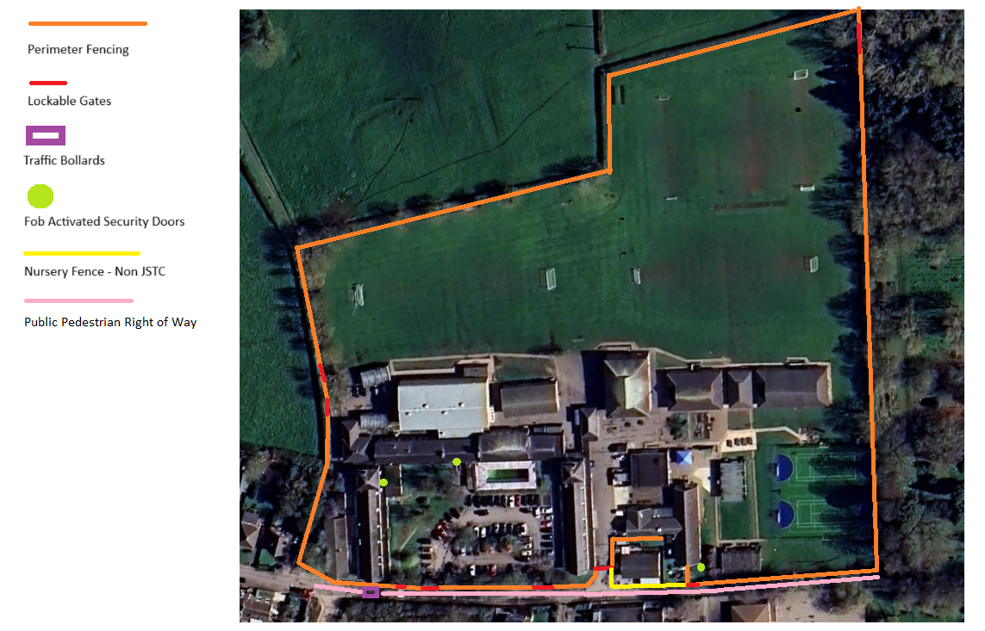

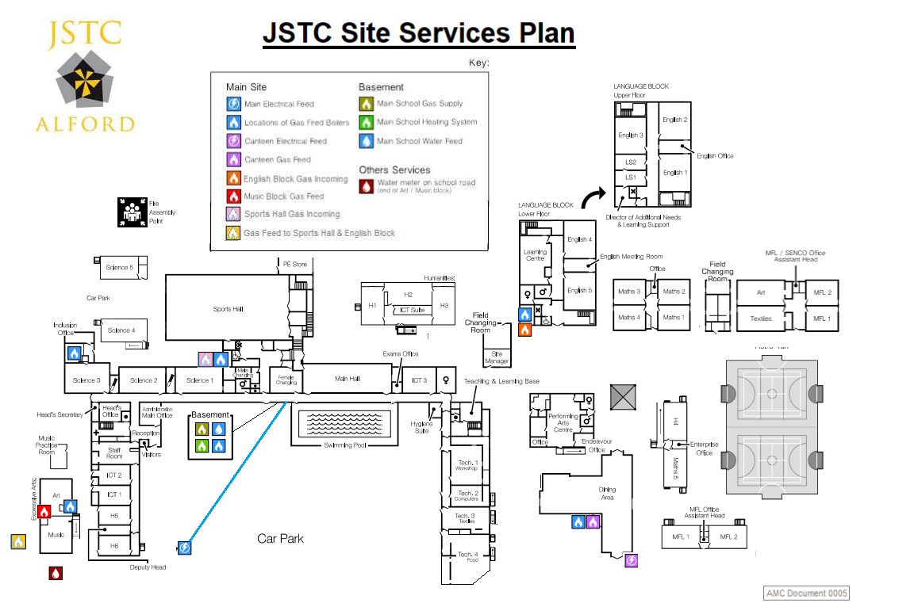

GENERAL SCHOOL RISK ASSESSMENT |  |  |  |  |  |  |  |  |  |  | 
PART A. ASSESSMENT DETAILS: JSTCRA0015 Site
Area/task/activity: JSTC Site Security

Location of activity: All JSTC Site

Team/School name:  Address & Contact details: |  |  | John Spendluffe Technology College Academy  Hanby Lane  Alford  LN13 9BL |  |  |  |  |  |  | Name of Person(s) undertaking Assessment: | Mark Bishell
 |  |  |  |  |  |  |  |  |  | Signature(s): | 
Line manager/Head Teacher (Name & Title): |  |  | Mr Simon Curtis - Head Teacher |  |  |  |  |  |  | Date of Assessment: | 04/02/2026
Signature: |  |  |  |  |  |  |  |  |  | Step 5 Planned Review Date: | 03/02/2027
How communicated to staff: |  |  | Via Health and Safety file on staff drive  Announcement in morning briefing |  |  |  |  |  |  | Date communicated to staff: | Immediate
PART B1. HAZARD IDENTIFICATION AND CONTROL MEASURES:
Step 1 Identify significant hazards | Step 2 Identify who might be harmed and how |  |  |  |  | Step 3 identify precautionary measures already in place
List of significant hazards  (something with the potential to cause harm) |  | Who might  be harmed? |  | Type of harm | Probability |  | Impact | Risk Rating | Existing controls  (Actions already taken to control the risk) |  |  | Probability | Impact | Residual Risk After Controls
Site Boundary/ Access to Site |  | Students, staff, visitors |  | Multiple types from threat of unauthorised access & egress to & from site | Medium |  | High |  | - Boundary fencing in place on all sides of JSTC site, Northern, Southern, Western & Eastern boundaries all fenced.  - Boundary fencing is 2.3m paladin  - Main access & egress points covered by CCTV  - Any gate access in the boundary fencing is lockable  - Traffic management rise & fall bollards in operation during school day – 0400 to 1540  - Western Boundary has pedestrian right of way for public access. Front of house facing this is secured via locked gates & mag lock doors |  |  | Low | Medium
Visitors to site |  | Students, staff, visitors |  | Multiple types from threat of unauthorised access & egress to & from site | Medium |  | High |  | - See boundary fencing hazard above  - All visitors report to Main Reception  - Reception is covered by CCTV system  - Visitors sign in & have DBS & ID checked where appropriate  - Visitors are collected from reception by the person they are visiting  - Internal access to school controlled by fob access system  - All staff have individually registered access fobs  - Visitors without required DBS status MUST be accompanied at all times whilst on site  - Staff encouraged to challenge visitors when seen unaccompanied on site |  |  | Low | Medium
Open access to front reception |  | Students, staff, visitors |  | Aggressive visitors, confrontation, mental & physical injuries | Medium |  | High |  | - CCTV fitted to reception with warning sign  - Fob activated security door in reception to prevent access directly into school corridor and admin area  - No access into reception office from reception area  - Security door in reception and admin area can be locked down via a panic button to prevent staff accidently walking in to any aggressive situation and to prevent accidental access being granted to potentially aggressive persons. This effectively makes the reception area a sterile zone. |  |  | Low | High
Multiple access & egress points to site |  | Students, staff, visitors |  | Multiple types from threat of unauthorised access & egress to & from site | Medium |  | High |  | - See boundary fencing hazard  - Lock the main site access gates near the canteen during the day – 0900-1530  - Lock the rear carpark gates during the day – 0900-1600  - Sports Hall doors to car park are mag locked with fob access  - Lock personnel gate from Tech to car park during the day  - Staff duty rota to maintain vigilance/awareness this helps secure the site.  - All access & egress points covered by CCTV system  - All visitors report to main reception  - All gates secured end of day as part of site lockup  - Car park gates locked end of day to prevent out of hours parking |  |  | Low | Medium
Nature reserve area |  | Students, staff, visitors |  | Physical injury through unsupervised access. Unauthorised persons able to hide in area | Medium |  | Medium |  | - Out of bounds to students unless for supervised activities  - Fencing provided between JSTC site & nature reserve to prevent students gaining unsupervised access. Part of Northern boundary fencing.  - Fencing provided between JSTC site & nature reserve to prevent any persons gaining access to JSTC site through the area  - Fencing has gated access which remains locked unless requested by staff for supervised activities  - CCTV coverage of gate area and field adjacent to nature reserve  - Nature reserve is next to Alford Cemetery, barbed wire fence separates the two areas. Installed by Alford Town Council & JSTC |  |  | Low | Low
Private access road to the school is a designated public right of way (pedestrian) and access to nursery and primary (pedestrian) |  | Students, staff, visitors, members of the public |  | Physical injuries from unauthorised vehicle access on private road | High |  | High |  | - See multiple points of access & egress hazard  - See boundary fencing hazard  - Traffic management policy in place  - Duty staff manage area at busy times  - Traffic management rise & fall bollards in operation during school day – 0400 to 1540  - Road markings installed to highlight traffic restrictions on private road and designate pedestrian walkway  - Condition of private road monitored and repairs made in timely manner  - Western Boundary has pedestrian right of way for public access. Front of house facing this is secured via locked gates & mag lock doors |  |  | Low | High
Unauthorised persons gain access to site |  | Students, staff, visitors |  | Aggressive persons, confrontation, mental & physical injuries | Medium |  | High |  | - See boundary fencing hazard  - See visitors to site hazard  - See multiple access & egress points hazard  - Lockdown policy in place & staff & students trained  - Critical incident management policy in place & communicated to staff – Currently in review to assess Martyns Law Implications  - All site areas internal & external covered by CCTV system  - Designated lockdown alarm tone through fire alarm system |  |  | Low | Medium
Premises & Grounds Security |  | Caretaker  Premises Manager  Cleaning Staff |  | Accident, injury, delayed assistance in emergency | Medium |  | Medium |  | - The premises are locked (but exit from inside is possible in case of emergency e.g. emergency fire exit push door) when school is closed and staff work alone.  - Systems for raising the alarm in the event of an unexplained absence or emergency are implemented  - Increased security with the use of CCTV, secure access & egress,  - Increased lighting at final exit doors |  |  | Low | Medium
Out of Hours Callouts – Alarm Calls |  | Caretaker  Premises Manager  Cleaning Staff  IT Manager |  | Accident, injury, aggressive persons, delayed assistance in emergency | Low |  | High |  | - Alarms monitored by external centre. Keyholder response  - Keyholder establishes situation on contact with call centre  - If Keyholder concerned then contacts secondary person to assist  - If on arrival to site Keyholder assess risk of intruder/fire present then contacts Police/Emergency services immediately and does not enter building  - See Personal Attack/Verbal Aggression below |  |  | Low | Medium
Lone Working in Workplace activity;  Isolated Location. |  | Caretaker  Premises Manager  Cleaning Staff |  | Accident, injury, delayed assistance in emergency | Medium |  | Medium |  | - Lone working is usually restricted to times when problems are less likely, i.e. when at least two persons are present in the school/building at vulnerable times (e.g. between 6:00 am and 8:30 am & 5:00 pm & 6:00 pm).  - Arrangements for regular contact between the lone worker and a member of staff are implemented.  - Use signing in and work location system that is monitored;  - CCTV Coverage across site, internal & external |  |  | Low | Medium
Lone Working in Workplace activity;  Isolated Location continued… |  |  |  |  | Medium |  | Medium |  | - emergency procedures in place for if a member of staff fails to report back or call in at the agreed time;  - Mobile phones, or two-way radios in use  - Remote manual or automatic alarm system in place ;  - no high risk tasks e.g. working at height, COSHH, Electrical work undertaken alone;  - Use of a near miss incident register, including verbal or threatened violence;  - All staff have Health & Safety training;  - Good housekeeping procedures and Hazard reporting procedure in place;  - Equipment stored correctly in designated areas;  - Personal protective equipment provided  - A well maintained security system at the building;  - Staff to have access to any risk assessment for particular hazardous task.  - Lighting on egress and exit routes, car parking zones. |  |  | Low | Medium
Personal Attack / Verbal Aggression |  | Caretaker  Premises Manager  Cleaning Staff  IT Manager |  | Accident, injury, aggressive persons, delayed assistance in emergency | Low |  | High |  | - Lone workers carry mobile phone to call for help.  - Before entering the grounds, the lone worker notifies someone of the situation, and their intention to investigate.  - They will make regular calls to those notified above to update them as to the situation.  - If a break-in has occurred, the lone worker will not attempt to enter the premises until the police arrive.  - If confronted by intruder(s) before the police arrive, the lone worker will not attempt to tackle or restrain them.  - Restraining of intruders should be left to the police who are trained in dealing with such situations.  - If the lone worker feels a situation is getting out of control, they will try not to freeze, keep moving, listening and talking to the person. They can often use the ‘talk and walk’ technique to either escape or walk the person to a populated work area, where it is safer.  - The lone worker will summon help from a colleague or supervisor if necessary. |  |  | Low | Medium
This general risk assessment will apply to this area/task/activity in most teams/schools providing the control measures described are in operation and there are no further local significant hazards. If it does not fully apply, please go to Part B2 on the next page. If it fully applies please sign below.

I certify that the risk assessment above fully applies to the area/task/activity under assessment in – John Spendluffe Tech College
Signed: Name: Mark Bishell Risk Assessor.

The Probability/Impact Matrix

High Probability

Medium Probability

Low Probability

 | Low  Impact | Medium  Impact | High  Impact

Key to the Shading Used in Table 1:
Unacceptable Risk – Immediate action to improve control is required

Acceptable Risk – Close monitoring is required and cost effective control improvements should be sought
Acceptable Risk – No action now but review periodically and consider possible low cost control improvements

If the control measures described are not in operation and further action is required or there are further local significant hazards please record these here, transfer any actions required to the Action Plan at Part C below and sign off below. Do not sign off above if further actions are required.

PART B2. HAZARD IDENTIFICATION AND CONTROL MEASURES:
Further significant hazards | Who might  be harmed? | Type of harm | Existing controls  (Actions already taken to control the risk)
Site boundary fencing weak points | Students, staff, visitors | Multiple types from threat of unauthorised access & egress to & from site | As listed above
Open access to front reception | Students, staff, visitors | Aggressive visitors, confrontation, mental & physical injuries | As listed above
Private access road to the school is a designated public right of way (pedestrian) and access to nursery and primary (pedestrian) | Students, staff, visitors, members of the public | Physical injuries from unauthorised vehicle access on private road | As listed above
Review arrangements in line with Martyns Law requirements | Students, staff, visitors, members of the public | Physical & mental injuries/effects from possible terrorist incident | As listed above

I certify that the assessment for the task/activity above covers all the significant hazards applicable

………….………………………. (name of Team /School).

Signed: Name: Simon Curtis (Line Manager/Headteacher).

PART C: ACTION PLAN Step 4 Further action / controls required
Hazard | Action required | Person(s) to undertake action? | Priority | Projected  time scale | Notes / comments | Date  completed
Site boundary fencing weak points | Installation of 2.3m paladin fencing to Eastern & Western boundaries to provide full boundary security | Premises Manager Charles Garth Consultants | High | Summer 2023 | Part of CIF Safeguarding bid Dec 2022. If bid unsuccessful then school will fund provision of Eastern boundary fencing as a minimum | Dec 2023
Open access to front reception | Remodelling of reception area office & admin managers office to provide secondary access routes into main building | Premises Manager Charles Garth Consultants | High | Summer 2023 | Part of CIF Safeguarding bid Dec 2022. Currently if reception area is locked down staff in offices in the reception area have no means of escape | August 2023
Private access road to the school is a designated public right of way (pedestrian) and access to nursery and primary (pedestrian) | Installation of permanent traffic barrier on access to private road. Fob activated for staff and intercom for authorised visitors or deliveries | Premises Manager Charles Garth Consultants | High | Summer 2023 | Part of CIF Safeguarding bid Dec 2022. Currently access is restricted at busy times but not during school day or out of hours | Feb 2023
Review arrangements in line with Martyns Law requirements | Further planning for emergency situations outside of school hours for events | JSTC SLT, Governors & Premises Manager | Medium | ASAP
Staff Training required on Martyns Law | Initial training/briefing required followed by regular security updates | Head Teacher & Premises Manager | Medium | ASAP

APPENDIX 2 – KEY CONTACT NUMBERS

As part of the emergency plan, this list of contacts should be obtained as a matter of course. Telephone numbers can be added to this page and the whole list MUST be updated regularly and frequently.

As a matter of urgency there will be a need for emergency telephone lines. Contact the Civil Protection Unit for Lincolnshire who is able to make these arrangements with British Telecom. Sections not complete are contacts known locally to you.

Contact | Name/Area | Telephone
A&E & Urgent Care Centres  at Local Hospitals | Lincoln A&E  Skegness Hospital  Skegness Urgent Care  Louth Urgent Care | 01522 512512  01754 762401 Main  01754 613504 Urgent Care  01507 600100 Ext 1223
Alford Police Station | Alford (not 24 hours) | 01507 462222
Chair of Governing Body | Liz Ramm | 01507 464963  07597 965458
Chief Executive Lincolnshire County Council | Debbie Barnes | 01522 553200
Child/Family Psychiatry & Counselling Service | CAMHS, Louth | 01507 606843
College Nursing Team | Spilsby | 01790 752609
East Midlands Ambulance Service (EMAS) | Control Room | 999
Environment Agency | General Enquiries | 03708 506506
Environment Agency | Incident Hotline | 0800 807060
Environment Agency | Floodline | 0345 988 1188
Executive Director of Children’s Services LCC | Heather Sandy | 01522 553200
JSTC’s Solicitors: Stone King | Roger Inman  Christopher Jones  Joanna Lake | 01223 612076  01225 326758  01223 612083
LCC Safeguarding / Child Protection  Social/Children’s Services Out of Hours | Lincoln – office hours  Emergency/out of hours | 01522 782111  01522 782333
LCC Safeguarding / Child Protection | Ruth Fox  Nicola Brangam | 01522 554695  01522 554674
Lincolnshire Centre for Grief and Loss | Lincoln | 01522 546168
Lincolnshire Civil Protection Unit – Emergency Planning | Working Hours  Out of hours | 01522 582220  01522 888111
Lincolnshire Fire and Rescue | Control Room | 999
Local Religious Groups: Priest in Charge,  Alford Group of Churches | Revd Ros Latham  Jen Cooper (office) | 01507 464859  01507 464855
PCSO Barnaby Prince | Alford | 07973 847267
Police | Control Room  Non Emergency Number | 999 non emergency 101  0300 111 0300
Press Contacts – Skegness Standard | Chrissie Redford; Editor  Email: | 07774 326173  chrissie.redford@jpress.co.uk
The Samaritans | Free from any phone | 116 123

The County Emergency Planning Unit should be used to mobilise wider responses.
The 01522 888111 number (Emergency Planning Officer) will connect to the Fire and Rescue control for out of hours emergencies. Ask them to inform the duty officer of the nature of the emergency and leave a number for a return call.

USEFUL CONTACTS

This information should be regularly checked and updated accordingly. – last updated Feb 2024

LINCOLNSHIRE COUNTY COUNCIL
Head of Education Support  (Matthew Clayton) | 07824 837006 (Office hours)  Email: matthew.clayton@lincolnshire.gov.uk
Director’s Office | 01522 550628 (Office hours)
Education Team | 01522 554590 (Office hours)  Email: educationteam@lincolnshire.gov.uk
Emergency Planning and Business Continuity Service | 01522 843402 (Office hours)  0141 397 9363 (Outside office hours, request a call back from the Emergency Planning Duty Officer)
Communications Team | 07920 889 243 (Office hours)
Educational Psychology Service | 01522 553473  Email: EP_admin@lincolnshire.gov.uk
Health and Safety Helpline | CorporateHealthAndSafety@lincolnshire.gov.uk
Advice for schools may be found on:
https://www.lincolnshire.gov.uk/school-pupil-support/assurance-lincolnshire/2
School Services Transport Team | 01522 782020
LCC Insurance Manager | insurance@lincolnshire.gov.uk  (LCC or buy-back only)
Educational Visits | EVOLVE system  https://evolve.edufocus.co.uk/evco10/unknown.asp
VINCI-Mouchel Property Service Centre  24hour helpdesk | 01522 555555  (LCC or buy-back only)
EMTET (Ethnic Minority & Traveler Education Team) | 01427 787190
Pupil Reintegration Team (PRT) | prt@lincolnshire.gov.uk  01522 555798 (North Lincolnshire)  01522 555816 (South Lincolnshire)
School Admission Team | schooladmissions@lincolnshire.gov.uk
The Specialist Teaching Team (STT) | STTenquiries@lincolnshire.gov.uk
Dyslexia Outreach Team | DyslexiaOutreach@lincolnshire.gov.uk  North: 07778 534478  South: 07717 226448
Enhanced Communication & Language Impairment provision for Students (ECLIPS) | ECLIPS@lincolnshire.gov.uk
Sensory Education and Support Team (SEST) | SEST_Team@lincolnshire.gov.uk  01522 553332
Liaise  (A parent support service, to signpost parents for support e.g. for appeals for exclusion, EHCP process etc.) | liaise@lincolnshire.gov.uk  0800 195 1635
TEACHER ASSOCIATIONS
National Association for Primary Education | 01604 647 646
NUT | 020 7388 6191
NASUWT | 0121 453 6150 – Headquarters  03330 145550 – Support & Advice
Association of Teachers and Lecturers | 0207 930 6441 – London Office
National Association of Headteachers | 0300 30 30 333
Association of School and College Leaders | 0116 299 1122
UNISON | 0800 171 2193 – Join  0800 0857 857 – Contact Us
RELIGIOUS ORGANISATIONS
Diocesan Education Trust | 01522 504010
Lincoln County Hospital Duty Chaplain | 01522 573080 – Non-urgent
Roman Catholic - Nottinghamshire Diocesan Board of Education | 01332 293833
Islamic Association of Lincoln | 01522 528743
Lincoln Jewish Minyan | info@lincolnjewishminyan.org.uk
LOCAL SERVICES AND ORGANISATIONS
Lincolnshire Here4You Advice Line – Healthy Minds Lincolnshire and CAMHS | 0800 234 6342  Grief and loss support packs are available to schools via LPFT's professionals hub (this is not a public facing resource page so please do not share the link outside of your setting)  www.lpft.nhs.uk/young-people/lincolnshire/professionals/service-offer-and-referrals/healthy-minds-lincolnshire/healthy-minds-and-mental-health-support-teams-resources  In addition self-help information is also publicly available to young people and parents/carers at www.lpft.nhs.uk/young-people/lincolnshire/young-people/helping-you-help-yourself
Lincolnshire Centre for Grief & Loss | 19 Carlton Mews, The Carlton Centre, Lincoln, LN2 4FJ  01522 546168  email@lcgl.org.uk
Working Together Team (WTT) | 01775 840250 (school office)  outreach@gosberton-house.lincs.sch.uk  https://www.wtt.org.uk/
Behaviour Outreach Support Service (BOSS) | https://www.family-action.org.uk/what-we-do/children-families/lincs-boss/  01507 308908
SEND Advice Line Lincolnshire (SALL) | https://www.lincolnshire.gov.uk/support-education/ask-sall  01522 553199
NATIONAL ORGANISATIONS
CRUSE Bereavement Care | 0808 808 1677 – Free helpline
Website: www.cruse.org.uk
www.hopeagain.org.uk (a site for young people)
Telephone counselling service for those who are bereaved and those who care for bereaved people. Can offer referrals to local Cruse branches and other bereavement and counselling services throughout the UK
The Compassionate Friends | 0345 123 2304 - Helpline
Website: www.tcf.org.uk
Support for bereaved parents who have lost a child of any age from any circumstances
Winston's Wish Family Line | 08088 020 021 – Free helpline
Website: www.winstonswish.org.uk
Information and guidance for families of bereaved children. Can provide contact details for local groups which support bereaved children
The Samaritans | 0116 123 / 08457 90 90 90
Website: www.samaritans.org
Confidential emotional support for anyone in a crisis
Survivors of Bereavement by Suicide | 0300 111 5065 – Helpline  0115 944 1117 – National Office
Website: www.uksobs.org
Can provide details of local self-help groups for those bereaved by suicide
Childline | 0800 1111 (free phone)  National help line for children
British Red Cross National Office  Advice on memorials and donations  44 Moorfields, London, EC2Y 9AL | 0344 871 11 11 - Helpline
National Society for Prevention of Cruelty to Children (NSPCC) | 0808 800 5000

DfE guidance
Emergency planning and response for education, childcare, and children’s social care settings

APPENDIX 3 - EVACUATION

Signals
Signal for fire evacuation | Fire Alarm
Signal for bomb evacuation | Fire Alarm followed by message to staff
Signal for all-clear | Loud Hailer – Message Delivered at Muster Point

Assembly points - fire evacuation
Fire evacuation assembly point A | School Field
Fire evacuation assembly point B | Alford Primary School

Assembly points - bomb evacuation
Bomb evacuation assembly point A | School Field
Bomb evacuation assembly point B | Alford Primary School

If the school has been evacuated and pupils are not able to return to school (or go home) it may be possible to relocate temporarily to another building (e.g. buddy school or place of safety).

Pre-identified buddy school / place of safety / rest centre
Name of premise | Alford Primary School
Type of premise | School
Contact name | Mrs Vicky Ross - Headteacher
Address | Hanby Lane Alford
Directions / map | Opposite John Spendluffe
Estimated travel time  (walking, with pupils) | 5 minutes

APPENDIX 4 - LOCKDOWN

Signals
Signal for Lockdown | Continual Beep Tone Through Fire Alarm System – Email to All Staff. Tone Will Continue Until Safe Condition Established
Signal for Lockdown Leading to Evacuation | Period of Silence After Continual Beep Tone Followed by Normal Fire Alarm to Signal Evacuation Required
Signal for Lockdown Lifted | Period of Silence After Continual Beep Tone Followed by A Short Burst Of Continual Beep Tone – Email to All Staff

Lockdown
Rooms most suitable for lockdown | All blocks lockable
Entrance points (e.g. doors, windows) which should be secured | All blocks have lockable exists and entry
Communication arrangements | - Two-way radios  - Classroom telephones  - Mobile phones  - Instant messaging / email as appropriate
Notes | Details of Reason for Lockdown will be shared with Staff where appropriate once Lockdown is over and Safe Condition established

Upon hearing the lockdown signal, take the action below. If someone is taken hostage on the premises, the school should seek to evacuate the rest of the site.

Ref’ | Initial response - lockdown | Tick / sign / time
L1 | Ensure all pupils are inside the school building. Alternatively, ask pupils to hide or disperse if this will improve their safety.
L2 | Lock / secure entrance points (e.g. doors, windows) to prevent the intruder entering the building.
L3 | Dial 999. Dial once for each emergency service that you require.
L4 | Ensure people take action to increase protection from attack:  - Block access points (e.g. move furniture to obstruct doorways)  - Sit on the floor, under tables or against a wall  - Keep out of sight  - Draw curtains / blinds  - Turn off lights  - Stay away from windows and doors.
L5 | Ensure that pupils, staff and visitors are aware of an exit point in case the intruder does manage to gain access.
L6 | If possible, check for missing / injured pupils, staff and visitors.
L7 | Remain inside until an all-clear has been given, or unless told to evacuate by the emergency services.

APPENDIX 5 - BOMB THREATS

- If you receive a telephone call from someone who claims to have information about a bomb, record as much information as possible.

- Contact the Police (999) and Headteacher / Deputy Headteacher immediately.

- Carry out further actions based on Police advice.

What gender was the caller?
- Male
- Female

Approximately how old was the caller?

Did the caller use a codeword?

Did the caller have an accent?

Did the caller sound familiar?

What sort of voice did the caller have?

- Normal
- Loud
- Quiet
- Whispered
- Clear
- Disguised
- Well spoken
- Poorly spoken
- Deep
- High pitched
- Hoarse
- Nasal
- Impediment
- Stutter
- Lisp
- Slurred
- Other

At what pace did the caller speak?

- Normal
- Quick
- Slow

What manner did the caller have?

- Normal
- Calm
- Excited
- Laughing
- Upset
- Angry
- Rational
- Irrational
- Irritated
- Muddled
- Other

Were there any distinguishable background noises?

Notes:

APPENDIX 6 - SUSPICIOUS PACKAGES

Postal bombs or biological / chemical packages might display any of the following signs:
- Excessive wrapping
- Grease marks or oily stains on the envelope / wrapping
- An unusual odour including (but not restricted to) ammonia, almonds or marzipan
- Discolouration, crystals or powder-like residue on the envelope / wrapping
- Visible wiring / tin foil
- Heavy weight for the size of the package
- Uneven weight distribution
- Too many stamps for the weight of the package
- Poor hand writing, spelling or typing
- Delivery by hand from an unknown source
- Wrongly addressed or come from an unexpected / unusual source
- No return address or a postmark that does not match the return address.

The likelihood of a school receiving a postal bomb or biological / chemical package is low. However, if you do receive a suspicious package carry out the actions below.

Ref’ | Initial response - upon receiving a suspicious package | Tick / sign / time
SP1 | Remain calm.
SP2 | Put the letter / package down gently and walk away from it:  - Do not touch the package further  - Do not move it to another location  - Do not put the package into anything (including water)  - Do not put anything on top of it.
SP3 | Note its exact location.
SP4 | Evacuate the building, keeping people away from the room as far as possible. Ensure that any assembly points are located away from the danger of flying glass.
SP5 | Notify the Police (999) and the Headteacher / nominated emergency contact immediately.
SP6 | Do not use mobile phones, two-way radios or sound the alarm using the break glass call points.

If anyone is exposed to a potentially hazardous substance carry out the actions below.

Ref’ | Initial response - if exposed to a potentially hazardous substance | Tick / sign / time
SP7 | Keep all persons exposed to the material separate from others, and available for medical examination. Ask them to remain calm and avoid touching their eyes, nose or any other part of their body.
SP8 | Ensure that ventilation / air circulation systems in the building have been turned off and that all doors (including internal fire doors) and windows have been closed.
SP9 | Anyone experiencing symptoms of chemical exposure (e.g. streaming eyes, coughs and irritated skin) should seek medical attention urgently.

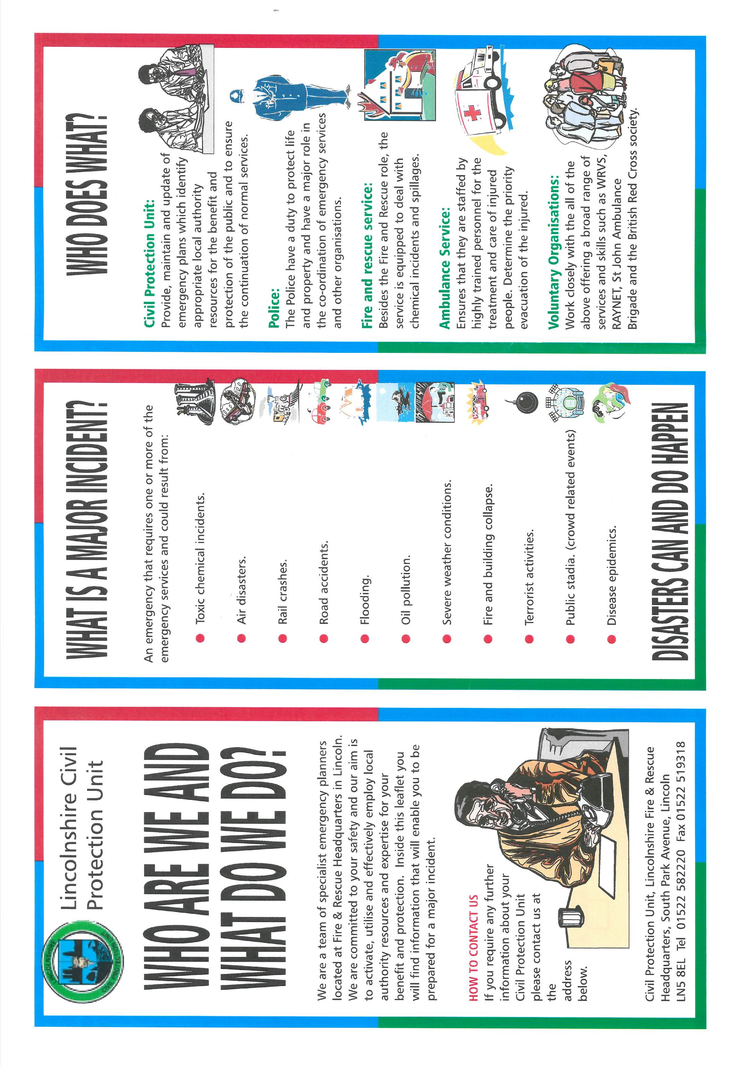



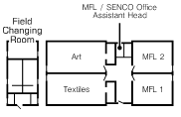
APPENDIX 7 – MARTYNS LAW CHECKLIST

What do you have in place? | Yes/No | For more information
Do you have protective security and preparedness plans (or critical incident plans, or similar) in place? | Yes. Critical Incident Plan & Lockdown Policy | Writing, testing and implementing your protective security and preparedness plans
Do you have a member of staff responsible for security? | Premises Manager? | Staff roles in protective security and preparedness work
Do you have plans in place that make your setting a less attractive target? | Yes, Boundary fencing, traffic control bollards, fob access entry points, CCTV, intruder alarms | Embedding a security culture
Do you have procedures for locking down rooms and invacuating people to protected spaces? | Lockdown procedure in place for day-to-day operation. Not for larger events such as Open Eve/Parents Evenings | Response options for your setting: lockdown, invacuation, evacuation
Do you have a range of muster points for evacuations? | 1 muster point within the secure school boundary. Secondary muster point is at ACPS if site evac required | Response options for your setting: lockdown, invacuation, evacuation
Do you have a flexible method for alerting staff to an incident and giving specific instructions? | 2 way radios, email, telephone, word of mouth | Communicating during an incident
Do you have a plan to warn neighbouring premises about an incident? | No | Communicating during an incident
Do you have emergency grab kits? | Some Medical kits for identified students | Compiling your grab kits
Do all of your staff know and understand what they may need to do in an incident? | Lockdown procedure is practiced once or twice a year. Key information delivered to staff in form of a crib sheet. | Writing, testing and implementing your protective security and preparedness plans
Do staff receive a protective security and preparedness induction and regular training? | Staff receive breifings on security & Lockdown along with information provided in document format for reference | Writing, testing and implementing your protective security and preparedness plans
Have you ever tested your plans to ensure they work? | Lockdown procedure is practiced once or twice a year. This is followed by a debrief meeting & action plan if required | Writing, testing and implementing your protective security and preparedness plans
Have you considered how this would work with learners or staff with SEND? | Currently no PEEPS in place | Tailoring your plan to your setting

What are your reflections on how prepared you already are, and what else may you need to do?

Overall, we have good procedures and processes in place that are practiced regularly & followed up with information being shared & any recommendations considered and where practicable implemented.

Action required around Lockdown & Incident management outside of day-to-day operation.

SEND need to assess their students on register and create PEEPS where appropriate.

Emergency Grab Bag not currently formalised

No formal mechanism to alert neighbouring properties/businesses

