Support For You to Access

Lincolnshire Helpline Details:

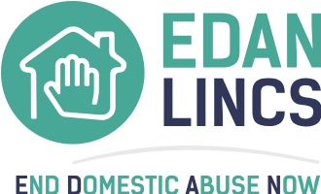
Need help? Call 01522 510041
9am - 5pm, Monday - Friday

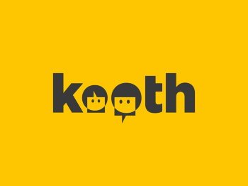

Kooth.com – www.kooth.com Counselling and support for young people aged 11-25



Healthy Minds – 01522 309777 (duty advice line) www.lincolnshire.gov.uk/ewb

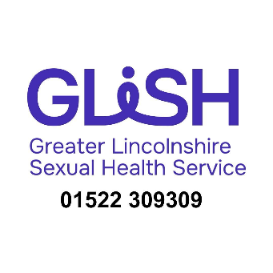

Lincolnshire Integrated Sexual Health (LISH) - 01522 309309 Advice and guidance page for Parents and Carers

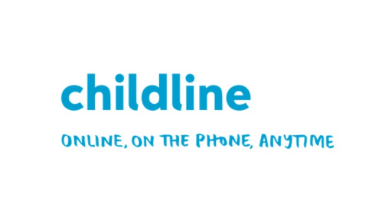
National Helpline Details:

Childline - Confidential FREE service for anyone under 18 - www.childline.org.uk or Tel: 0800 1111

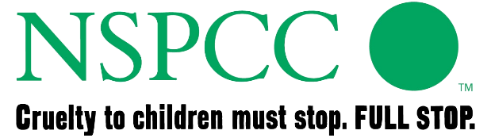

NSPCC (24/7) - 0808 800 5000

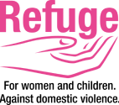
National Domestic Abuse Helpline – 0808 2000 247

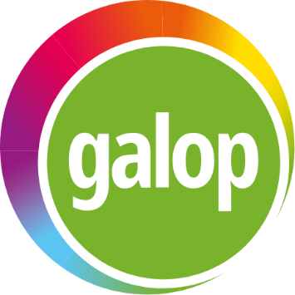

​ National LGBT+ Domestic Abuse Helpline: 0800 999 5428 or help@galop.org.uk
​


Alcohol and Drug Support Details:

contact: www.wearewithyou.org.uk

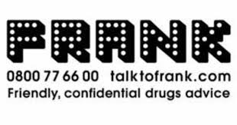

https://www.talktofrank.com/



https://www.nhs.uk/

In an emergency dial 999 - Contact your local police station

If you are suspicious or have any concerns that a Child is suffering or is likely to suffer 'Significant Harm', including any form of mistreatment or abuse, please call the Customer Service Centre (CSC) on 01522 782111
If you have concerns about the immediate safety of a child, you can call Lincolnshire Police on 101 or, in an emergency, dial 999

